***Use this word document to describe all your steps after each problem. Show all commands & screen pages and describe your steps. Points are deducted for missing steps.***

Describe all steps for each problem set and capture screen shots for each step with a JPG image within this document. Do not forget to put your name on the top of this file for your submitted homework. Also, please replace _ALL_ text in red with your information! Please include in your MS Word document only relevant portions of the console output or output files. Sometime either console output or the result file is too long and including it into the MS Word document makes that document too hard to read. PLEASE DO NOT EMBED files into your MS Word document. You are not obliged to use Java or Eclipse. You are welcome to use any language and any IDE of your choice.

**Problem 1:**

Consider file import-85.csv with car characteristics and prices. Extract 4 features you consider most relevant for setting the price of the automobile and use regression techniques discussed in the class and Azure Machine Learning Studio to create a model predicting car price based on those features. Run you model using three of existing regression algorithms and report which of them is the most accurate with the given set of features. Please be aware that Neural Network Regression model might take several hours and we recommend that you do not use it. Make sure you remove any and all of Azure resources once you are done.

**Total points: 100**

Put all your steps and screen captures here.

The basic steps of create a new pipeline is as follows:

* Import data.
* Prepare data.
* Train a machine learning model.
* Evaluate a machine learning model.

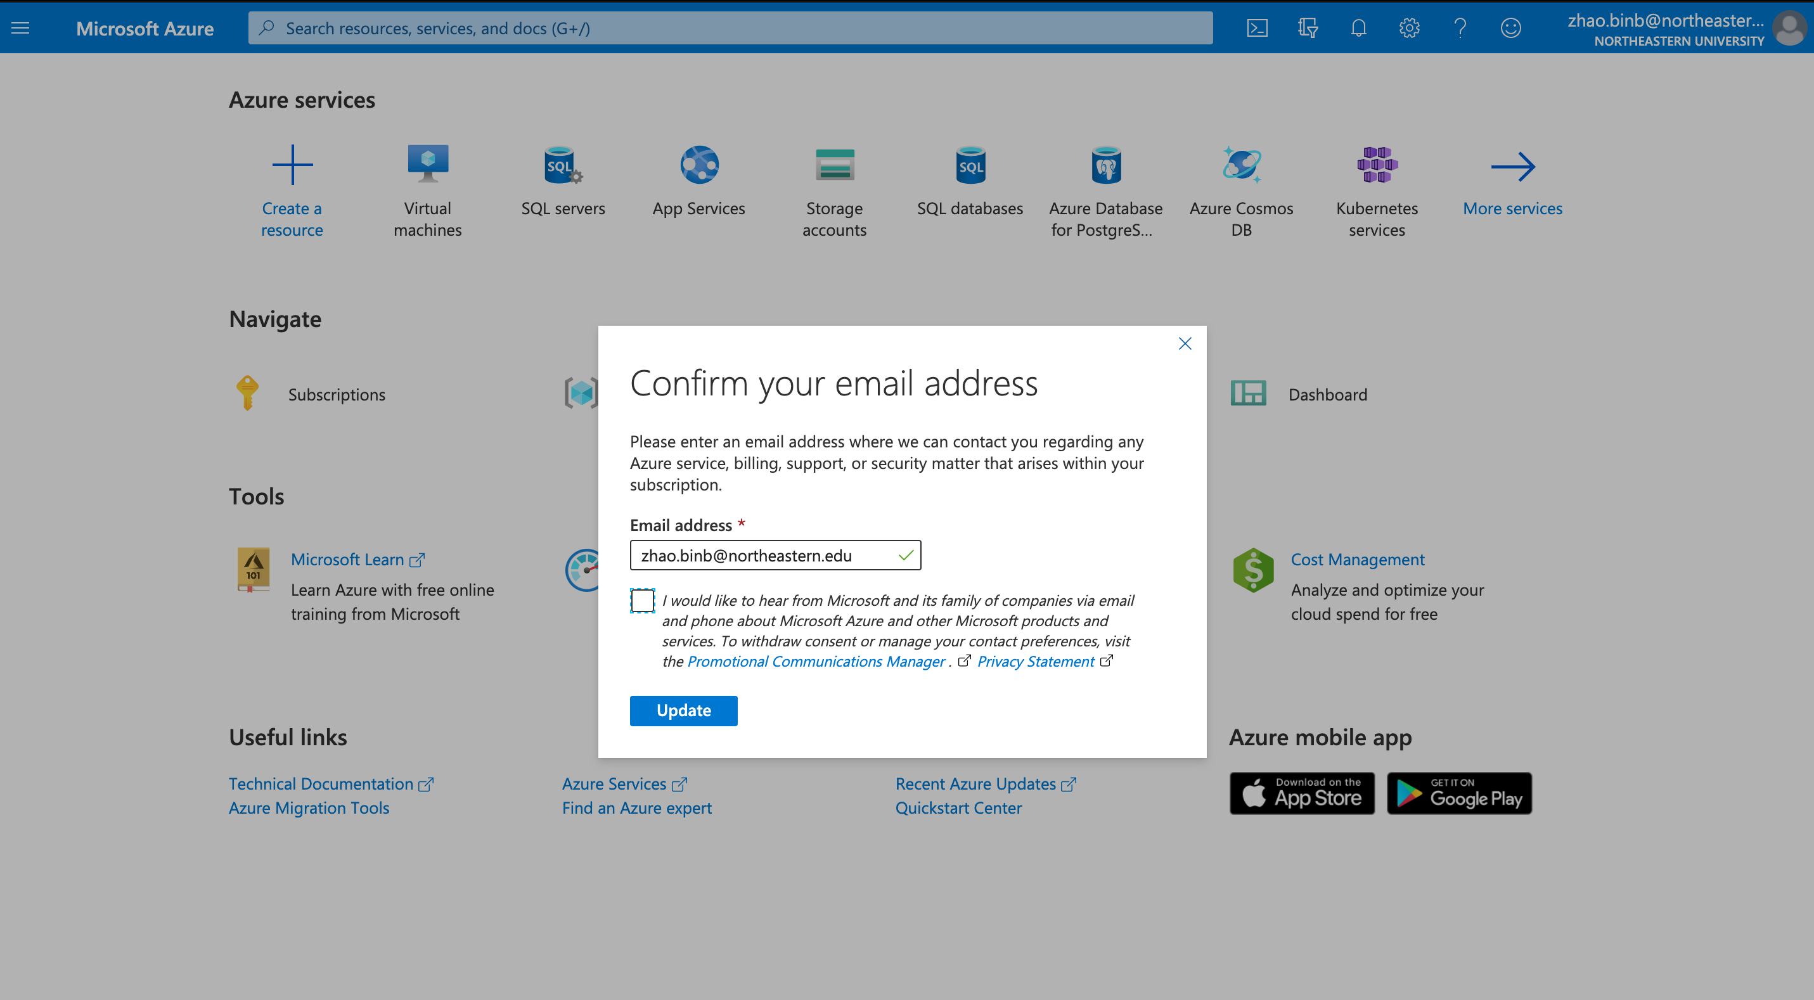

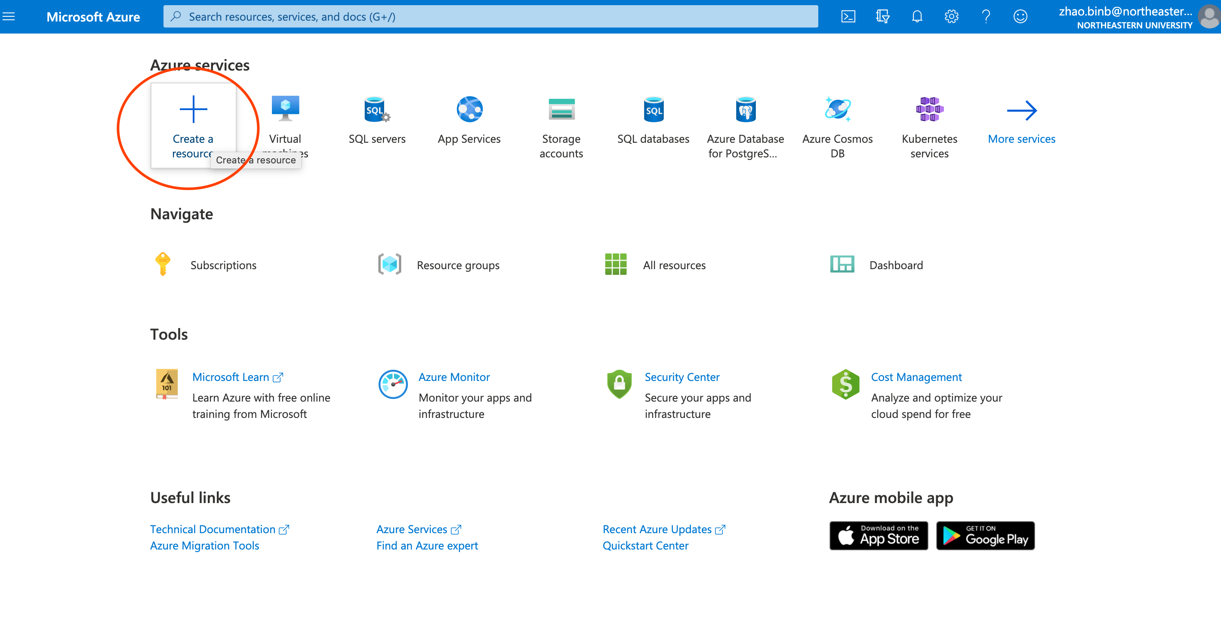

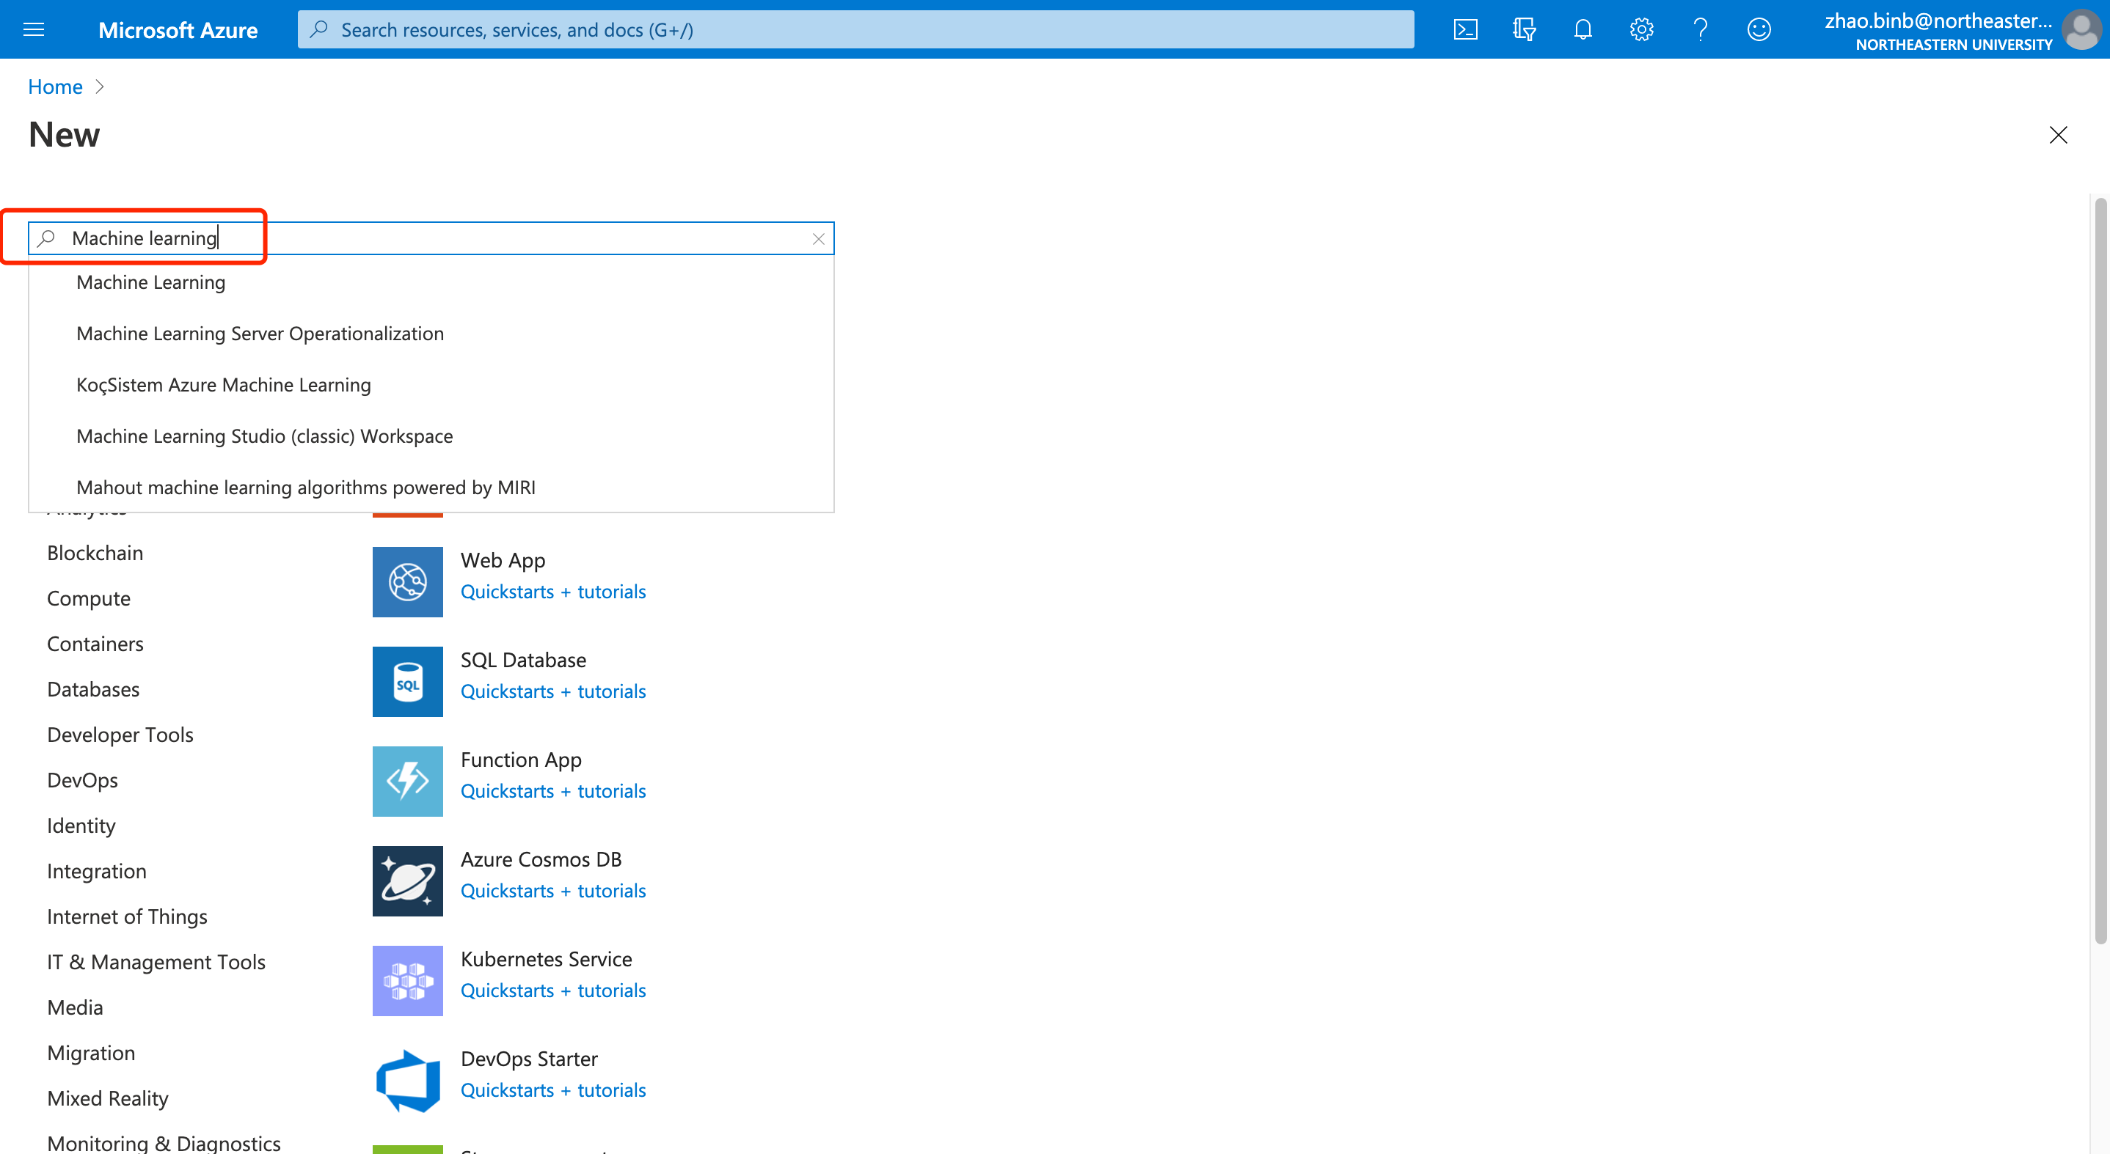 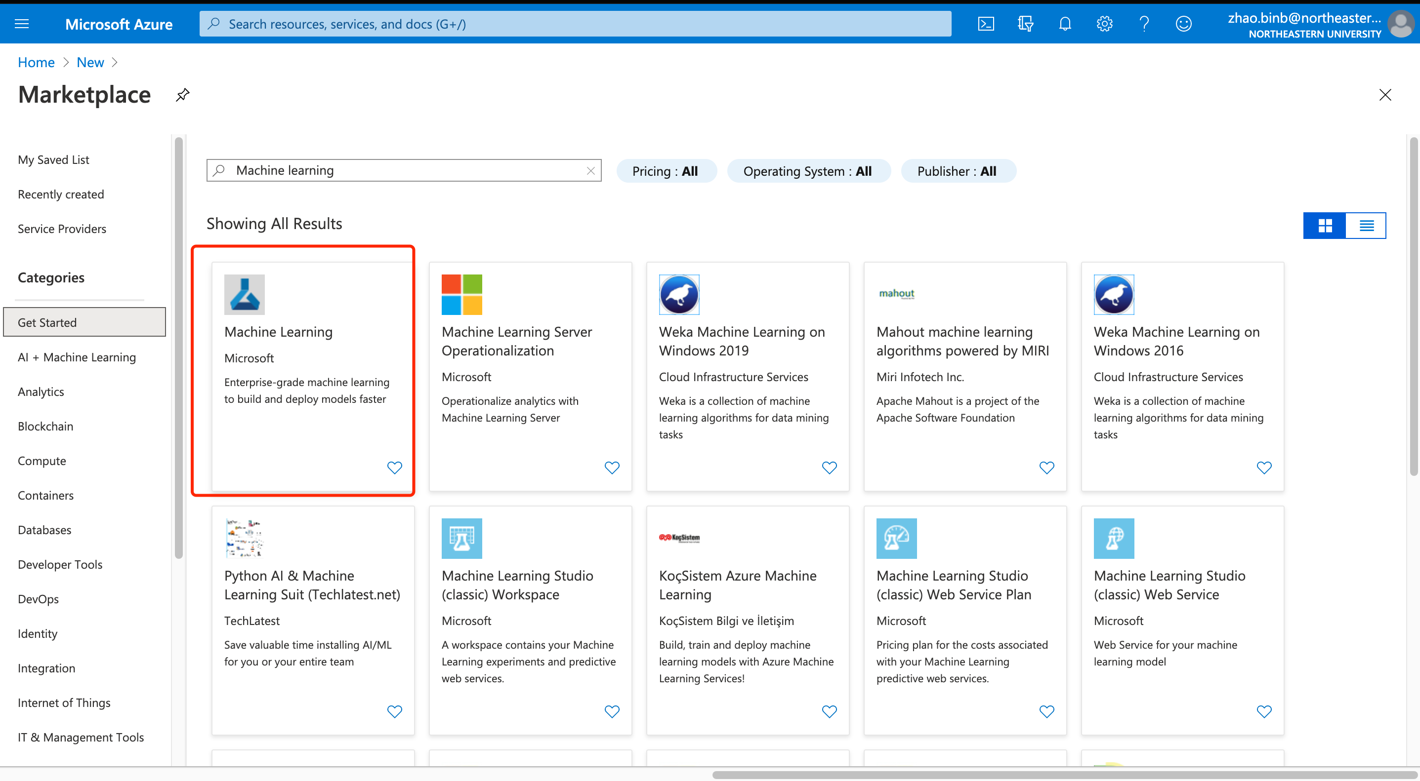 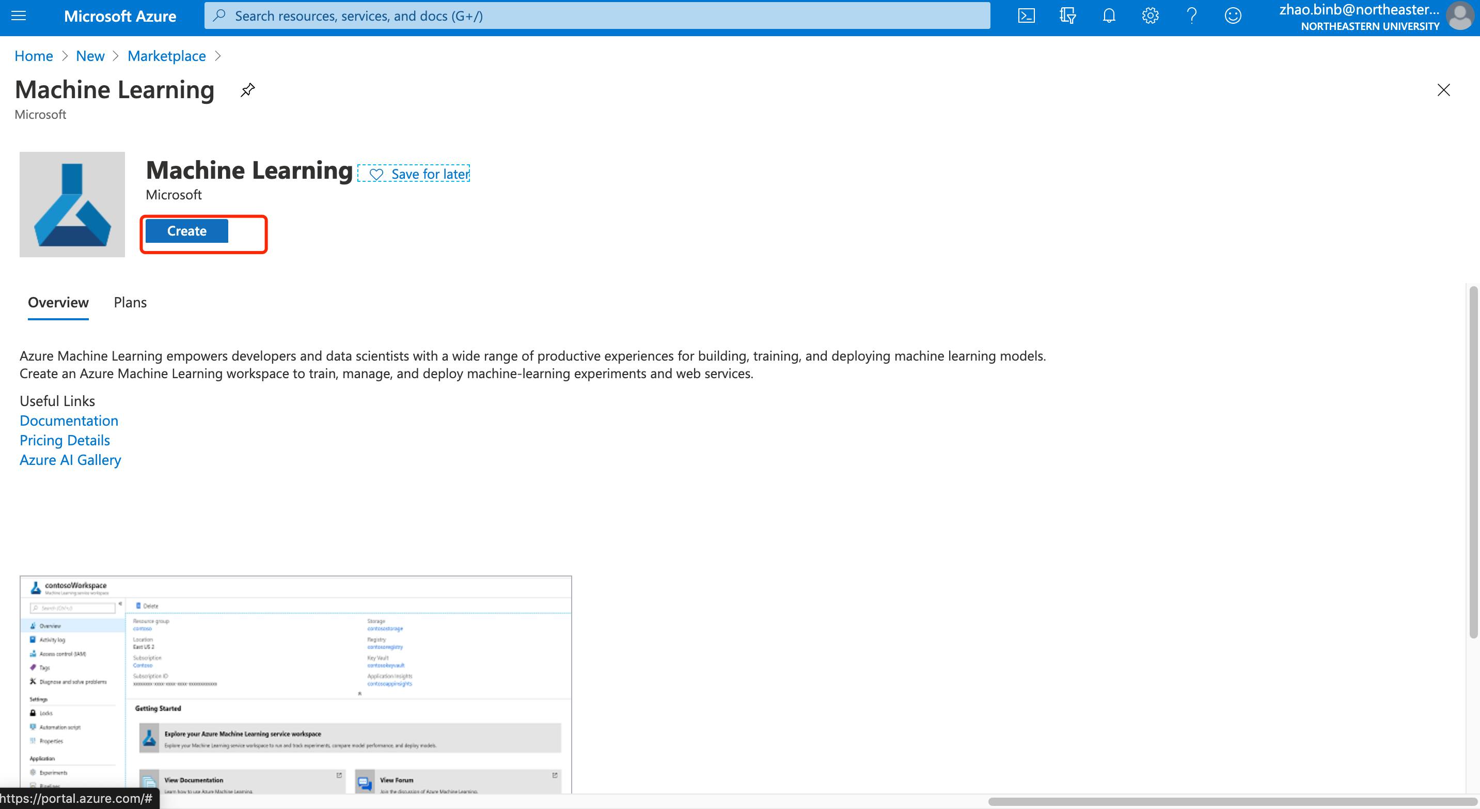 configure the new workspace, use the name NEU

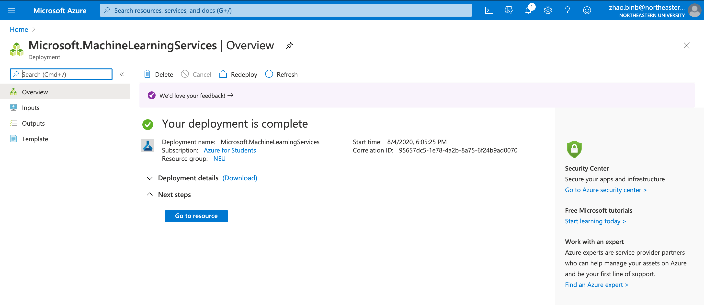

After created the resources, go to ml.azure.com, and select the workspace

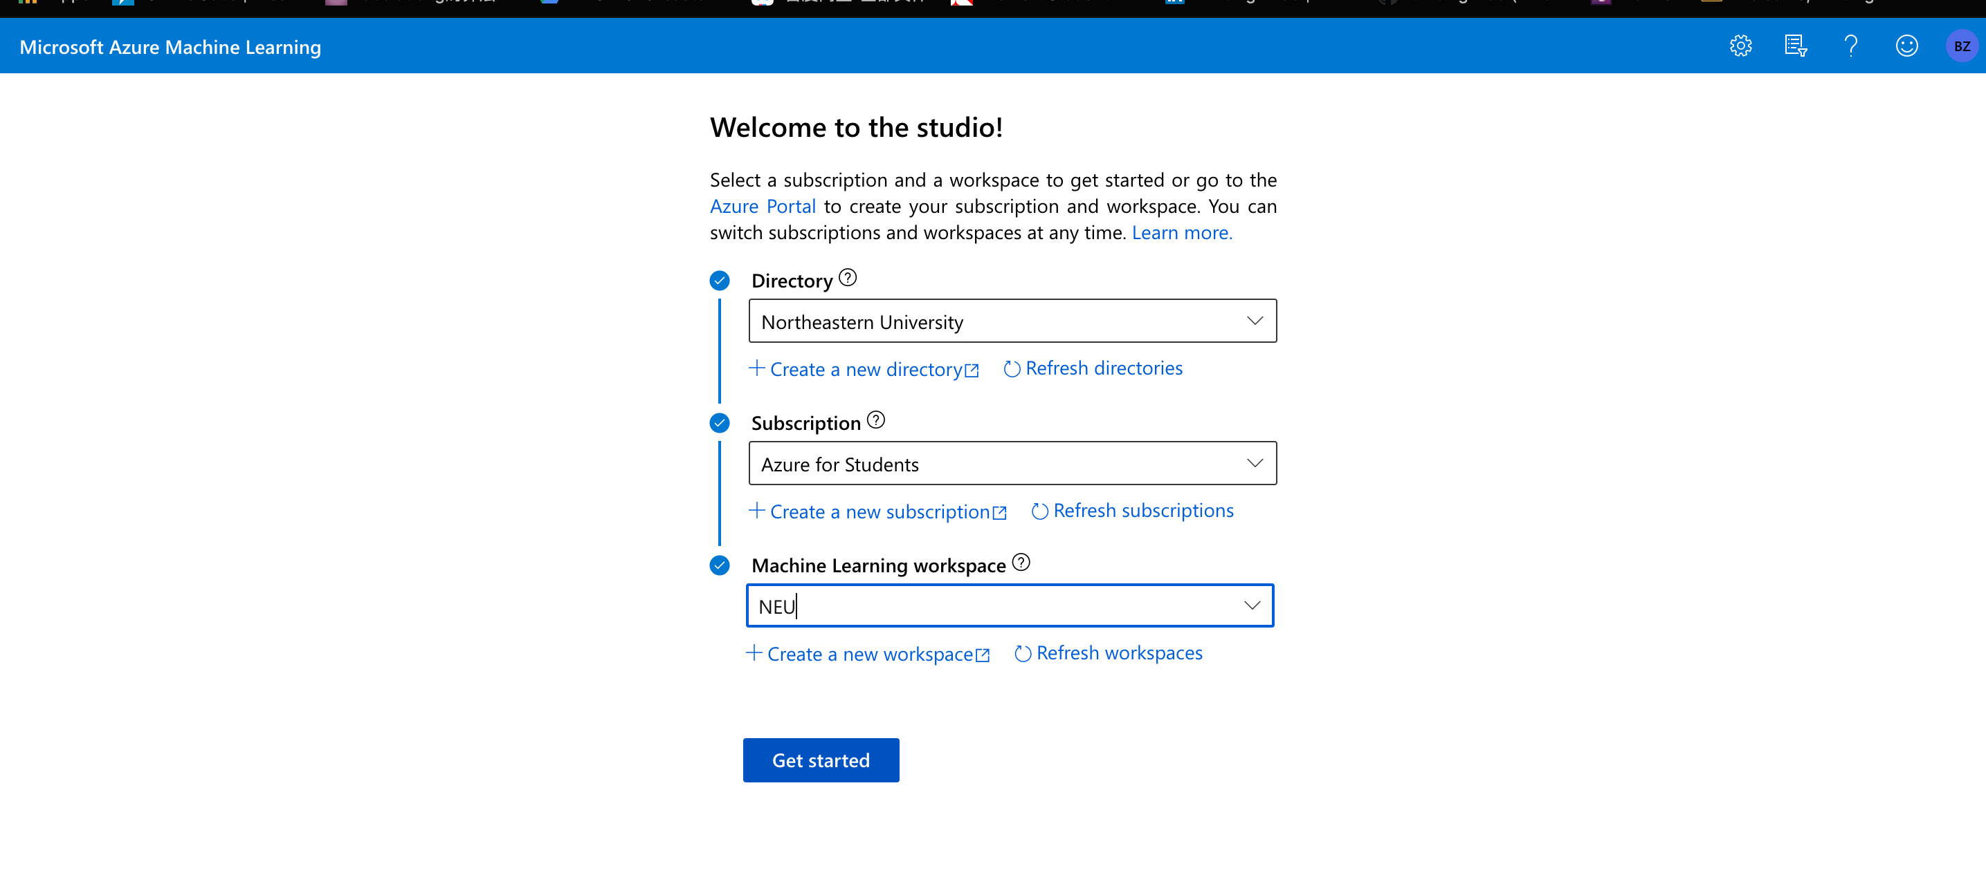 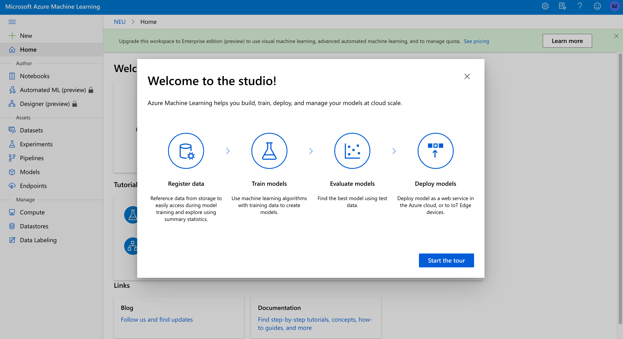

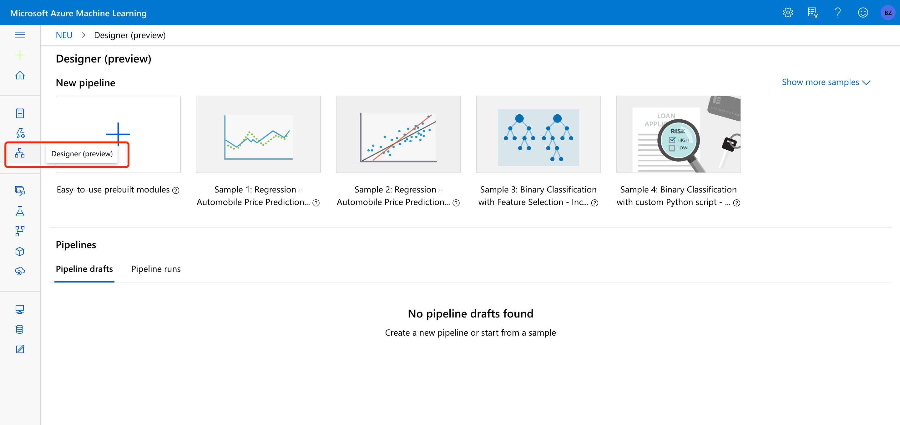

Click designer to create new pipeline and select Easy-to-use prebuilt modules

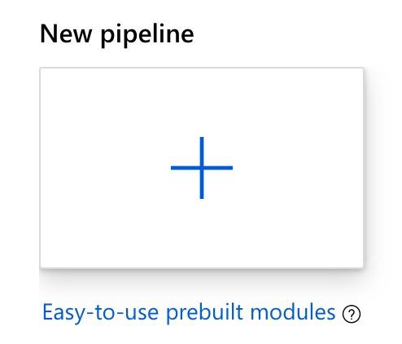

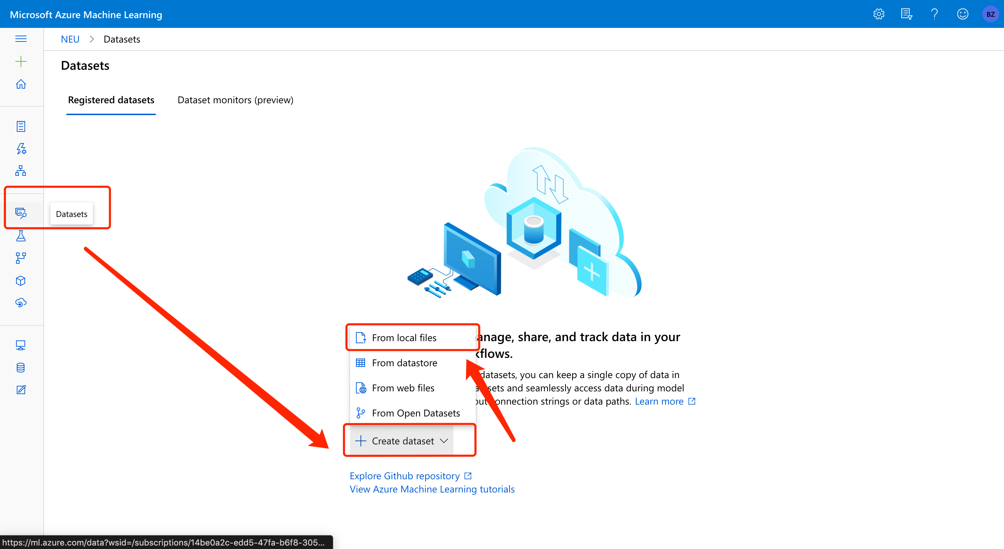

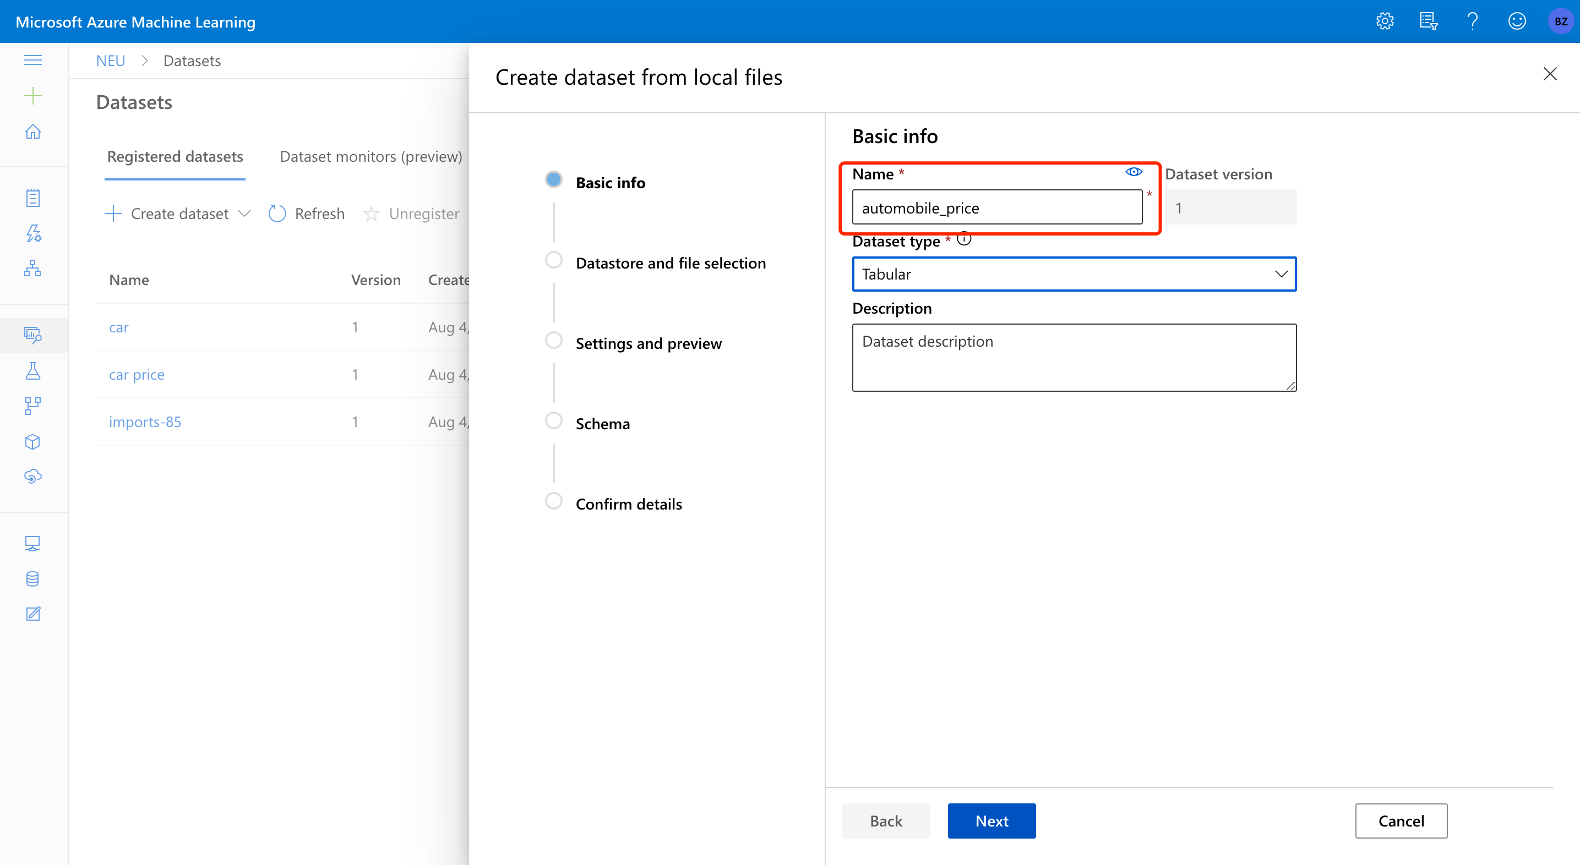

Choose the “combine headers from all files” to include the headers

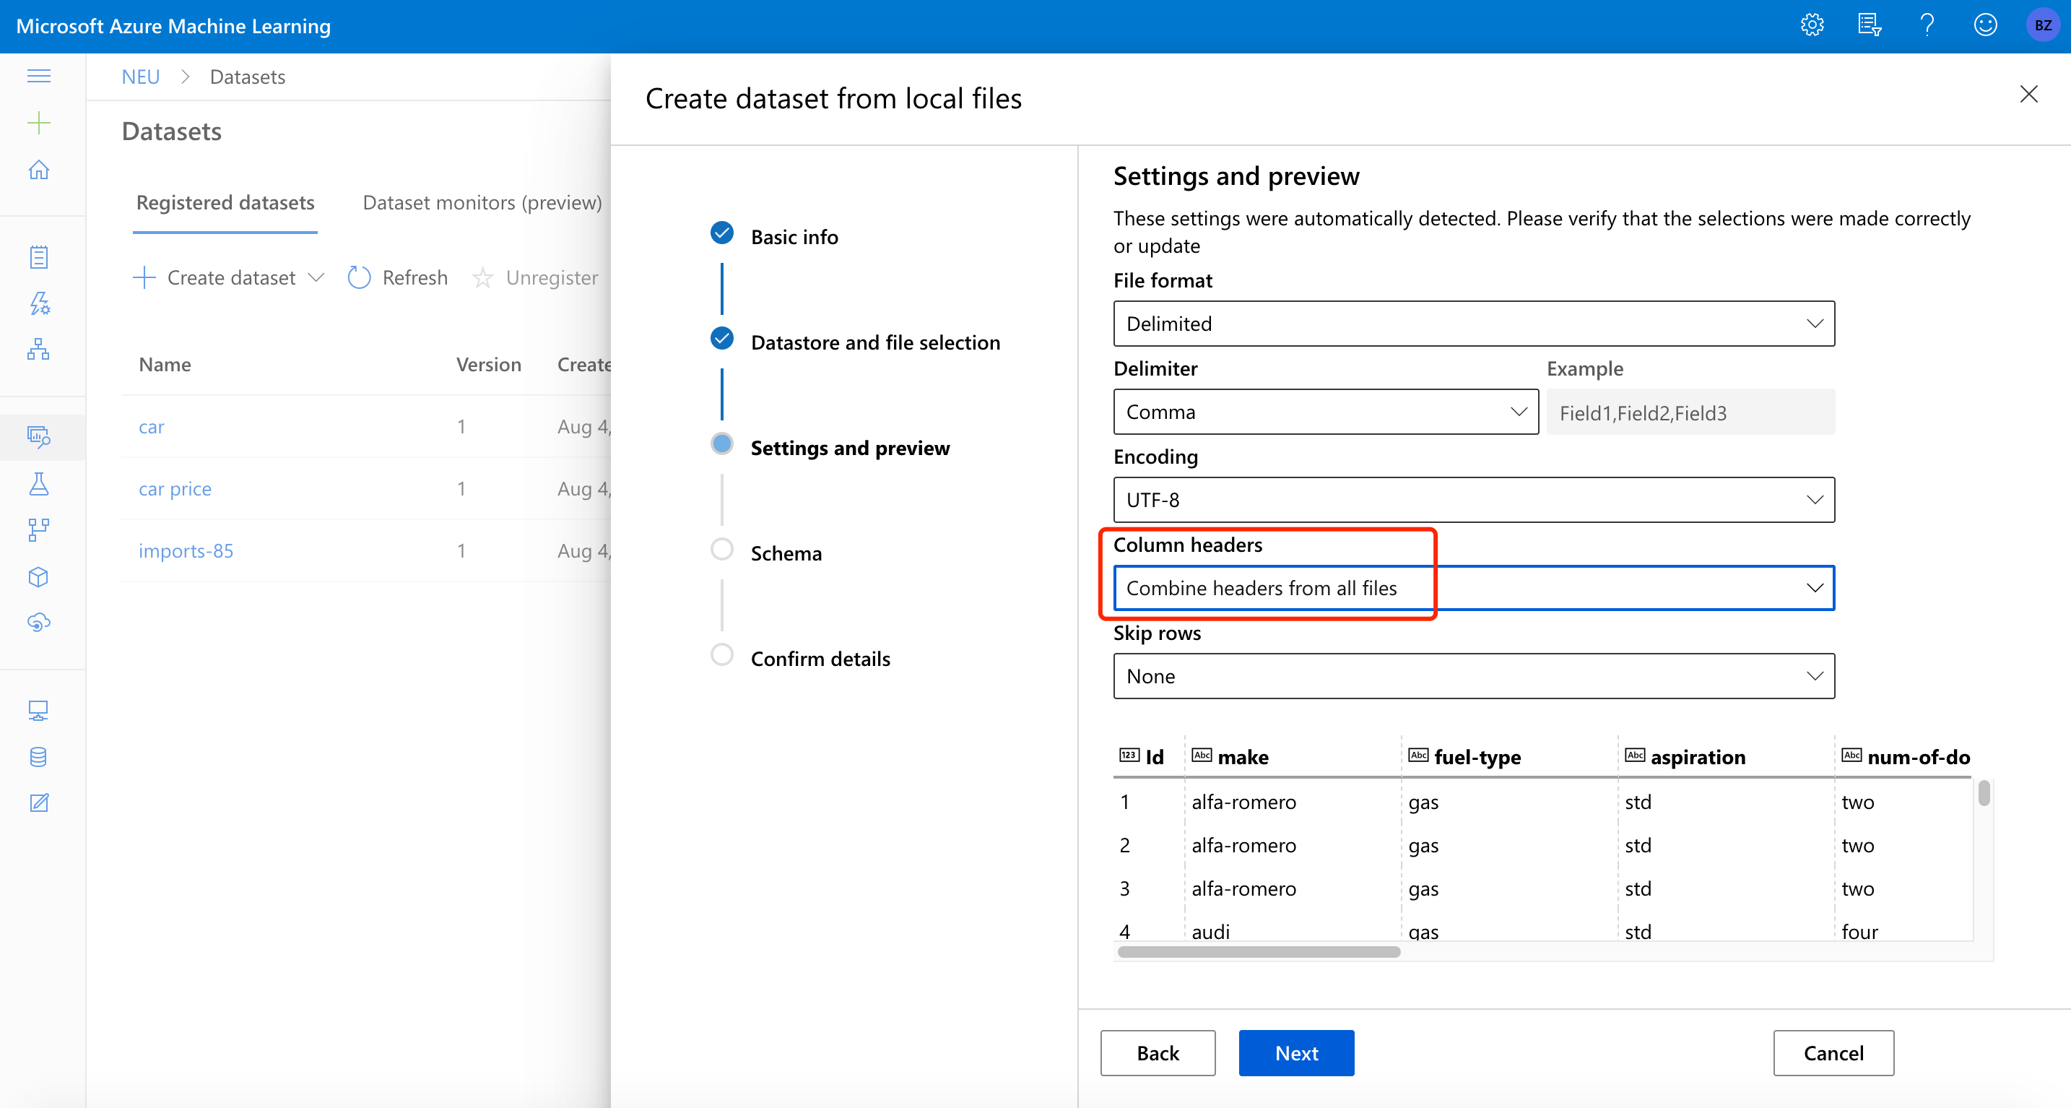

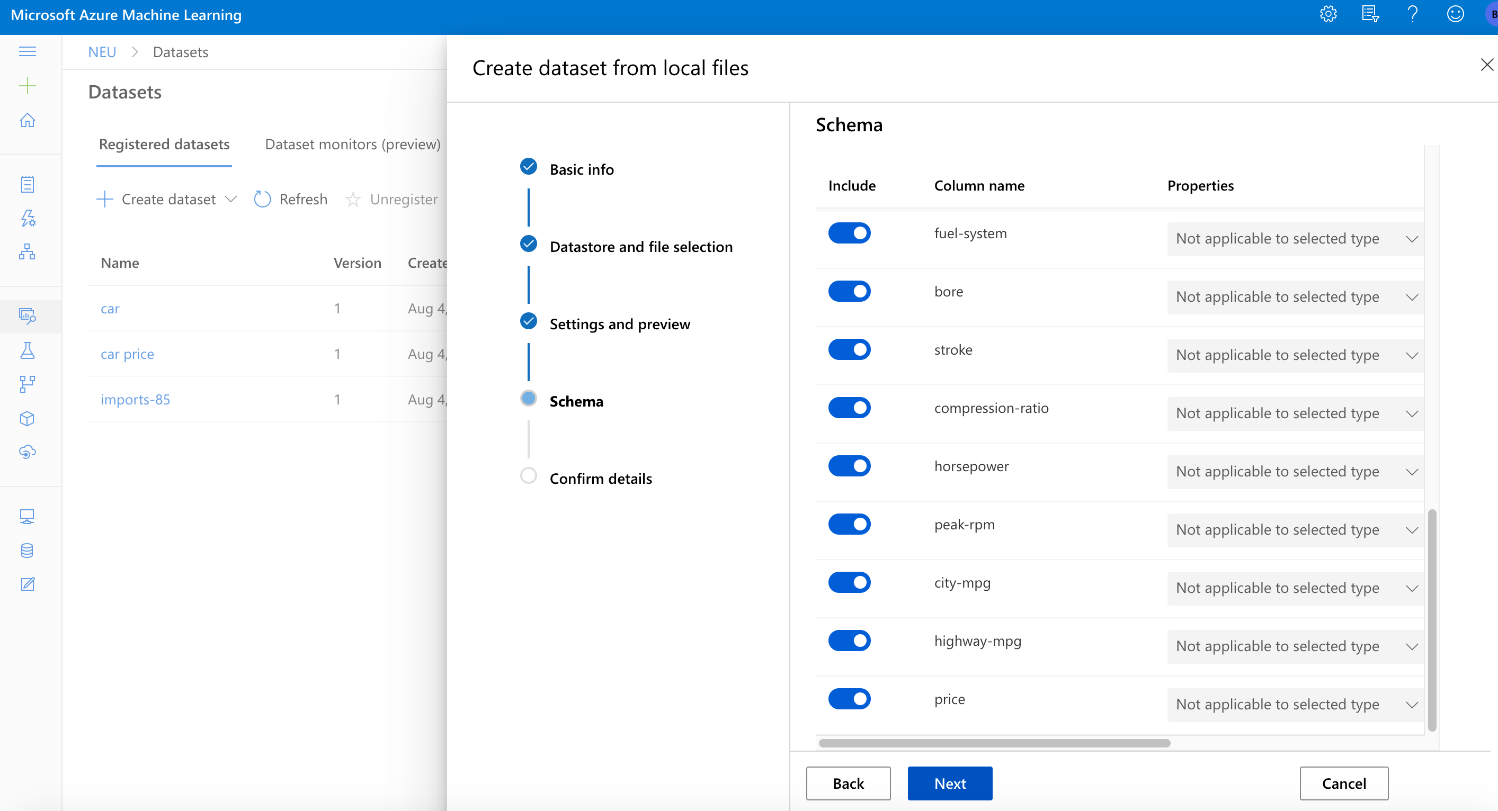

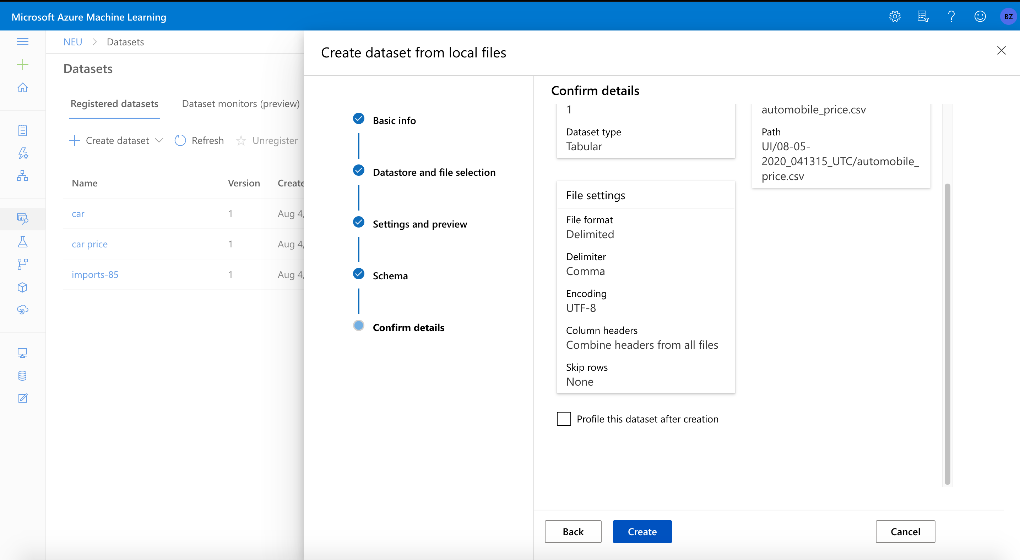 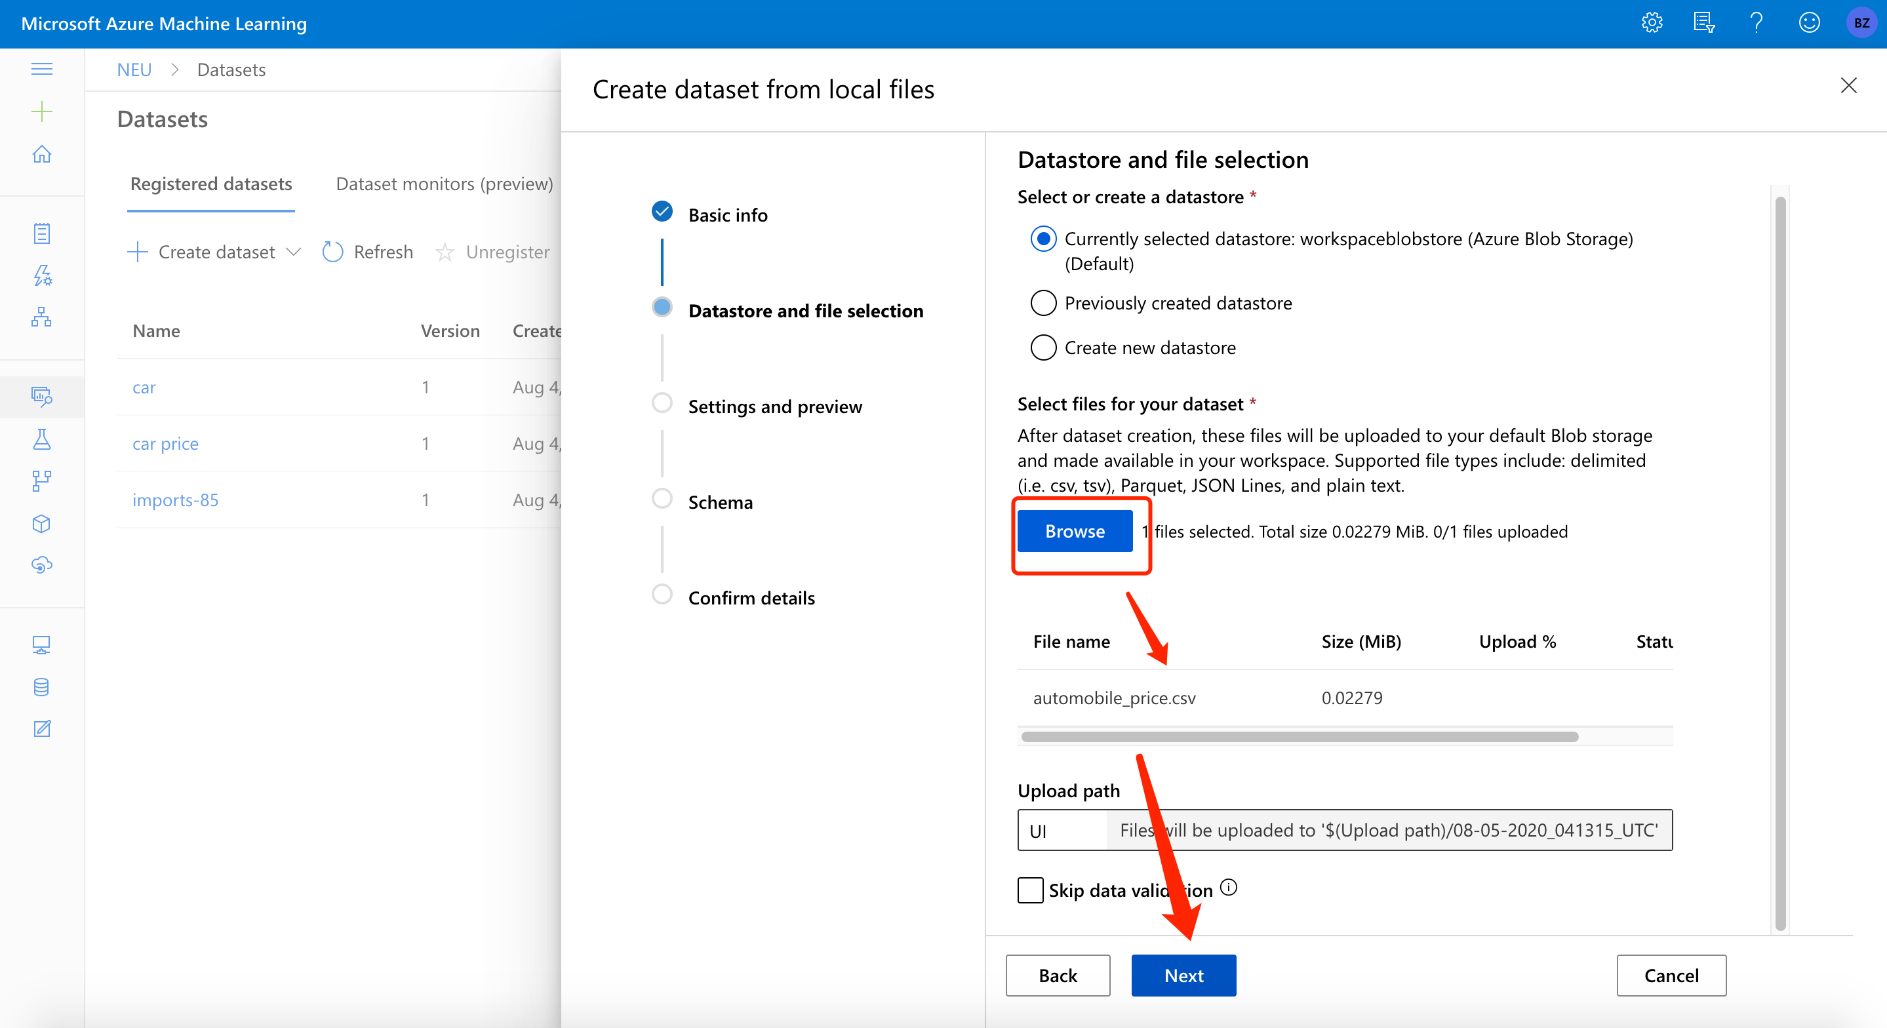

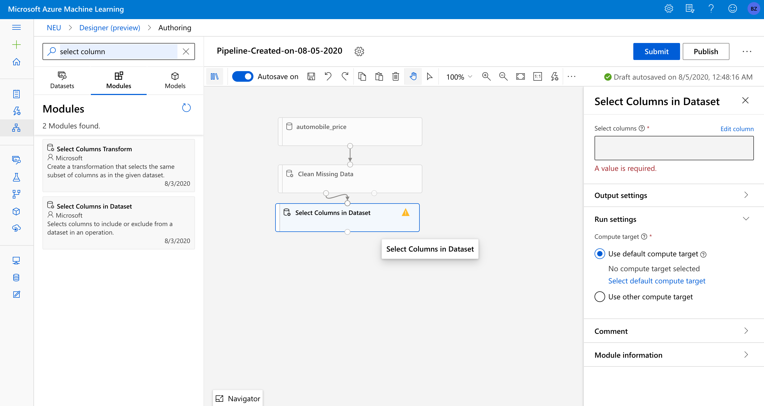

Then we can click desinger and create new pipeline:

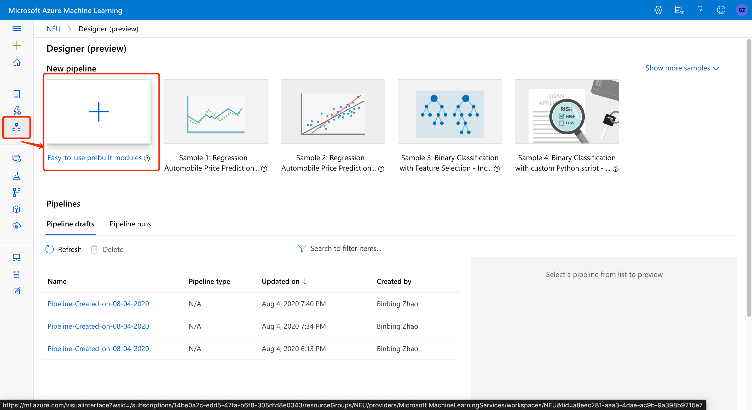

Click the dataset and drag it to the pipeline

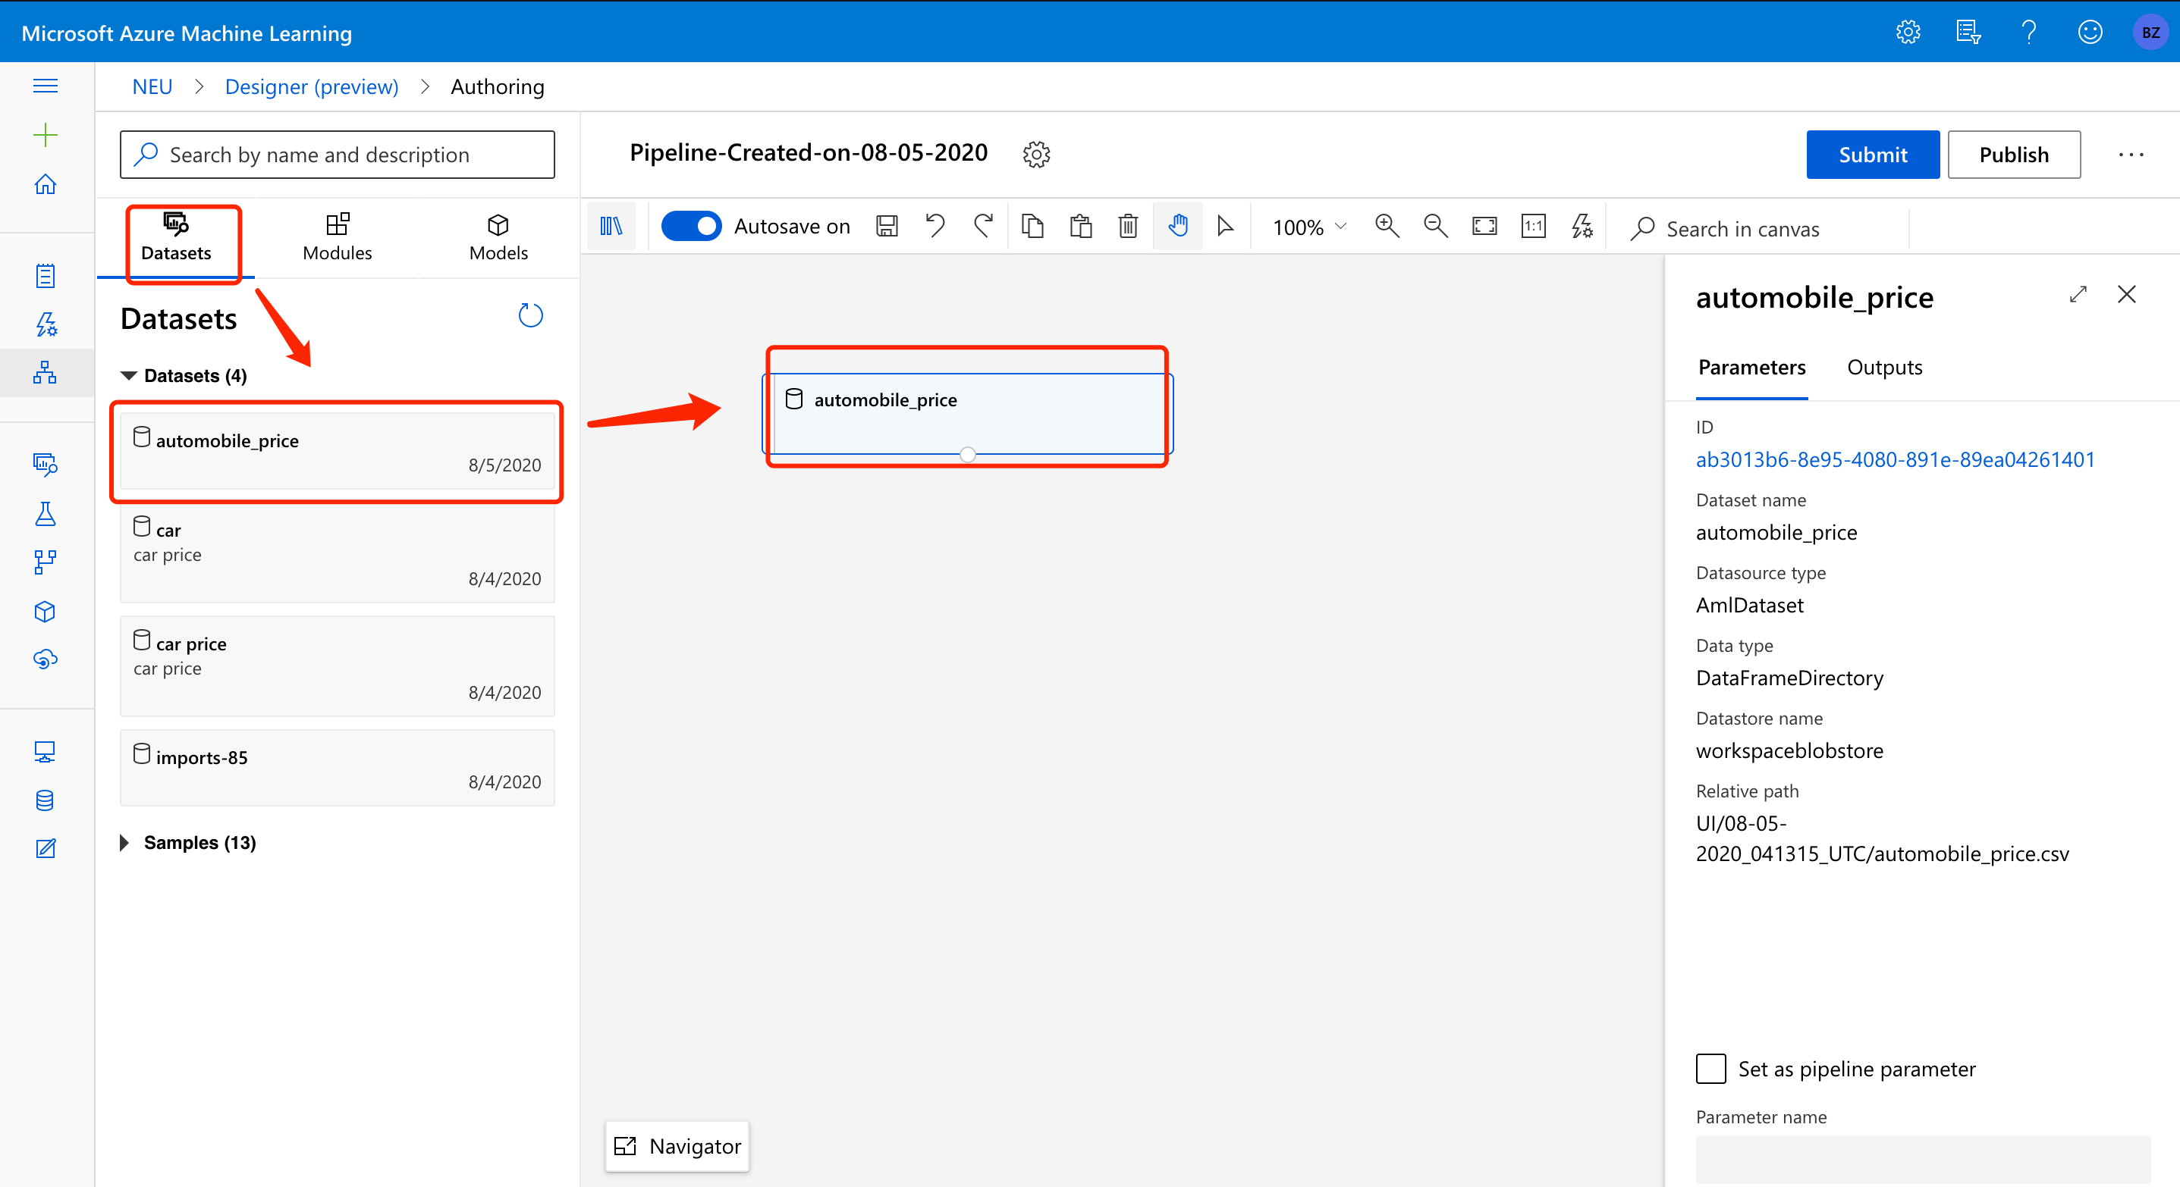

Clean missing value:

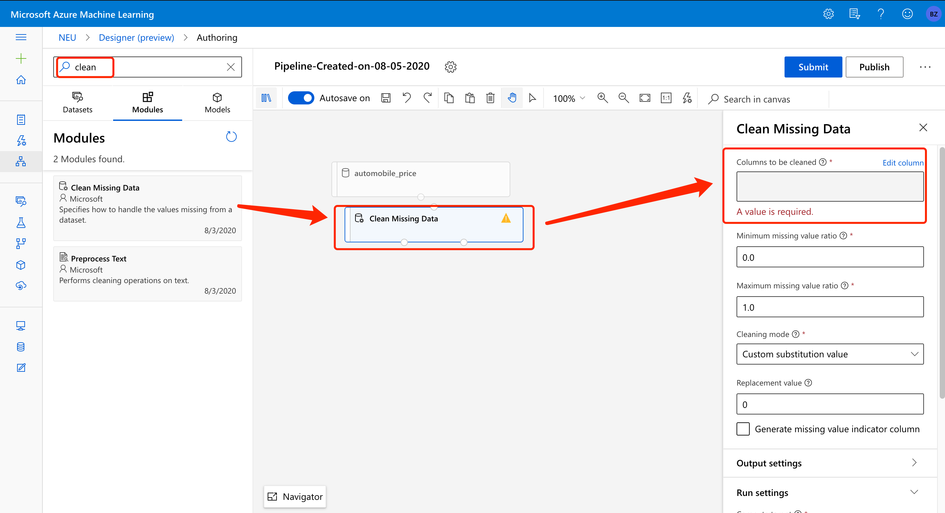

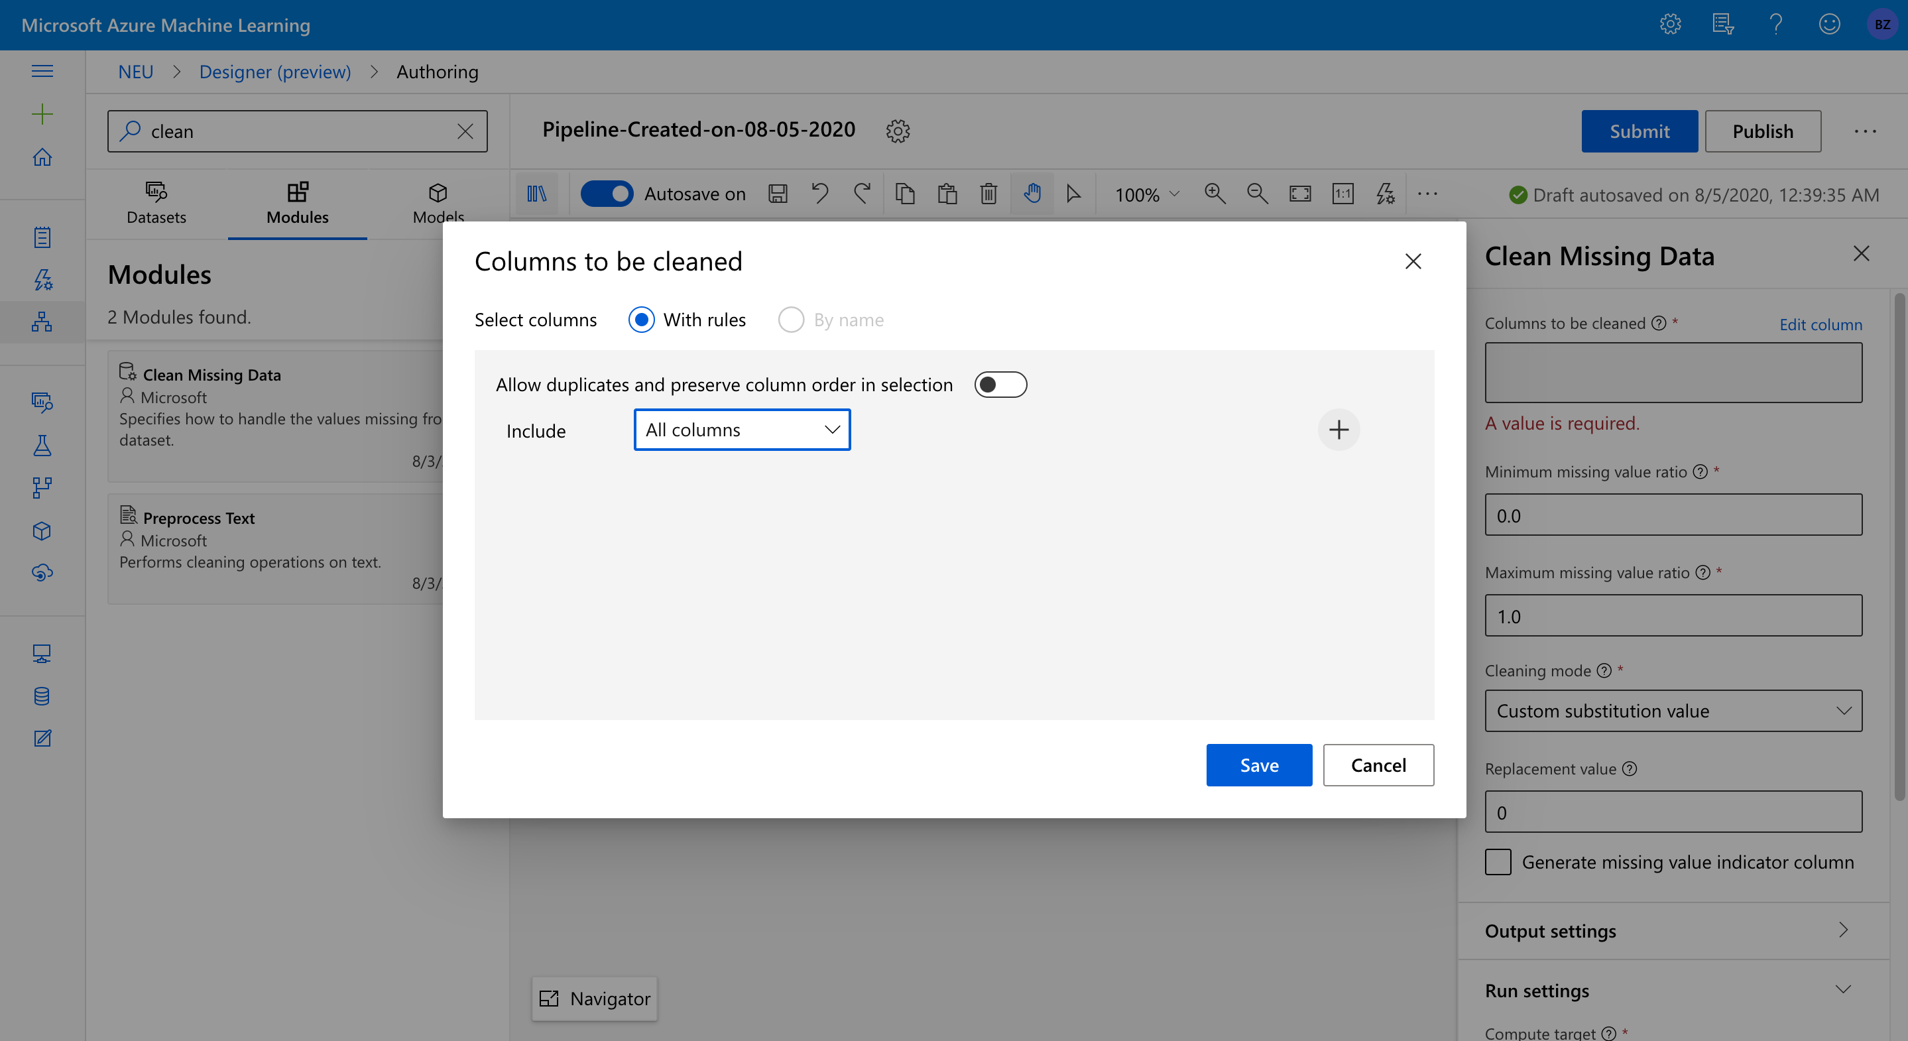

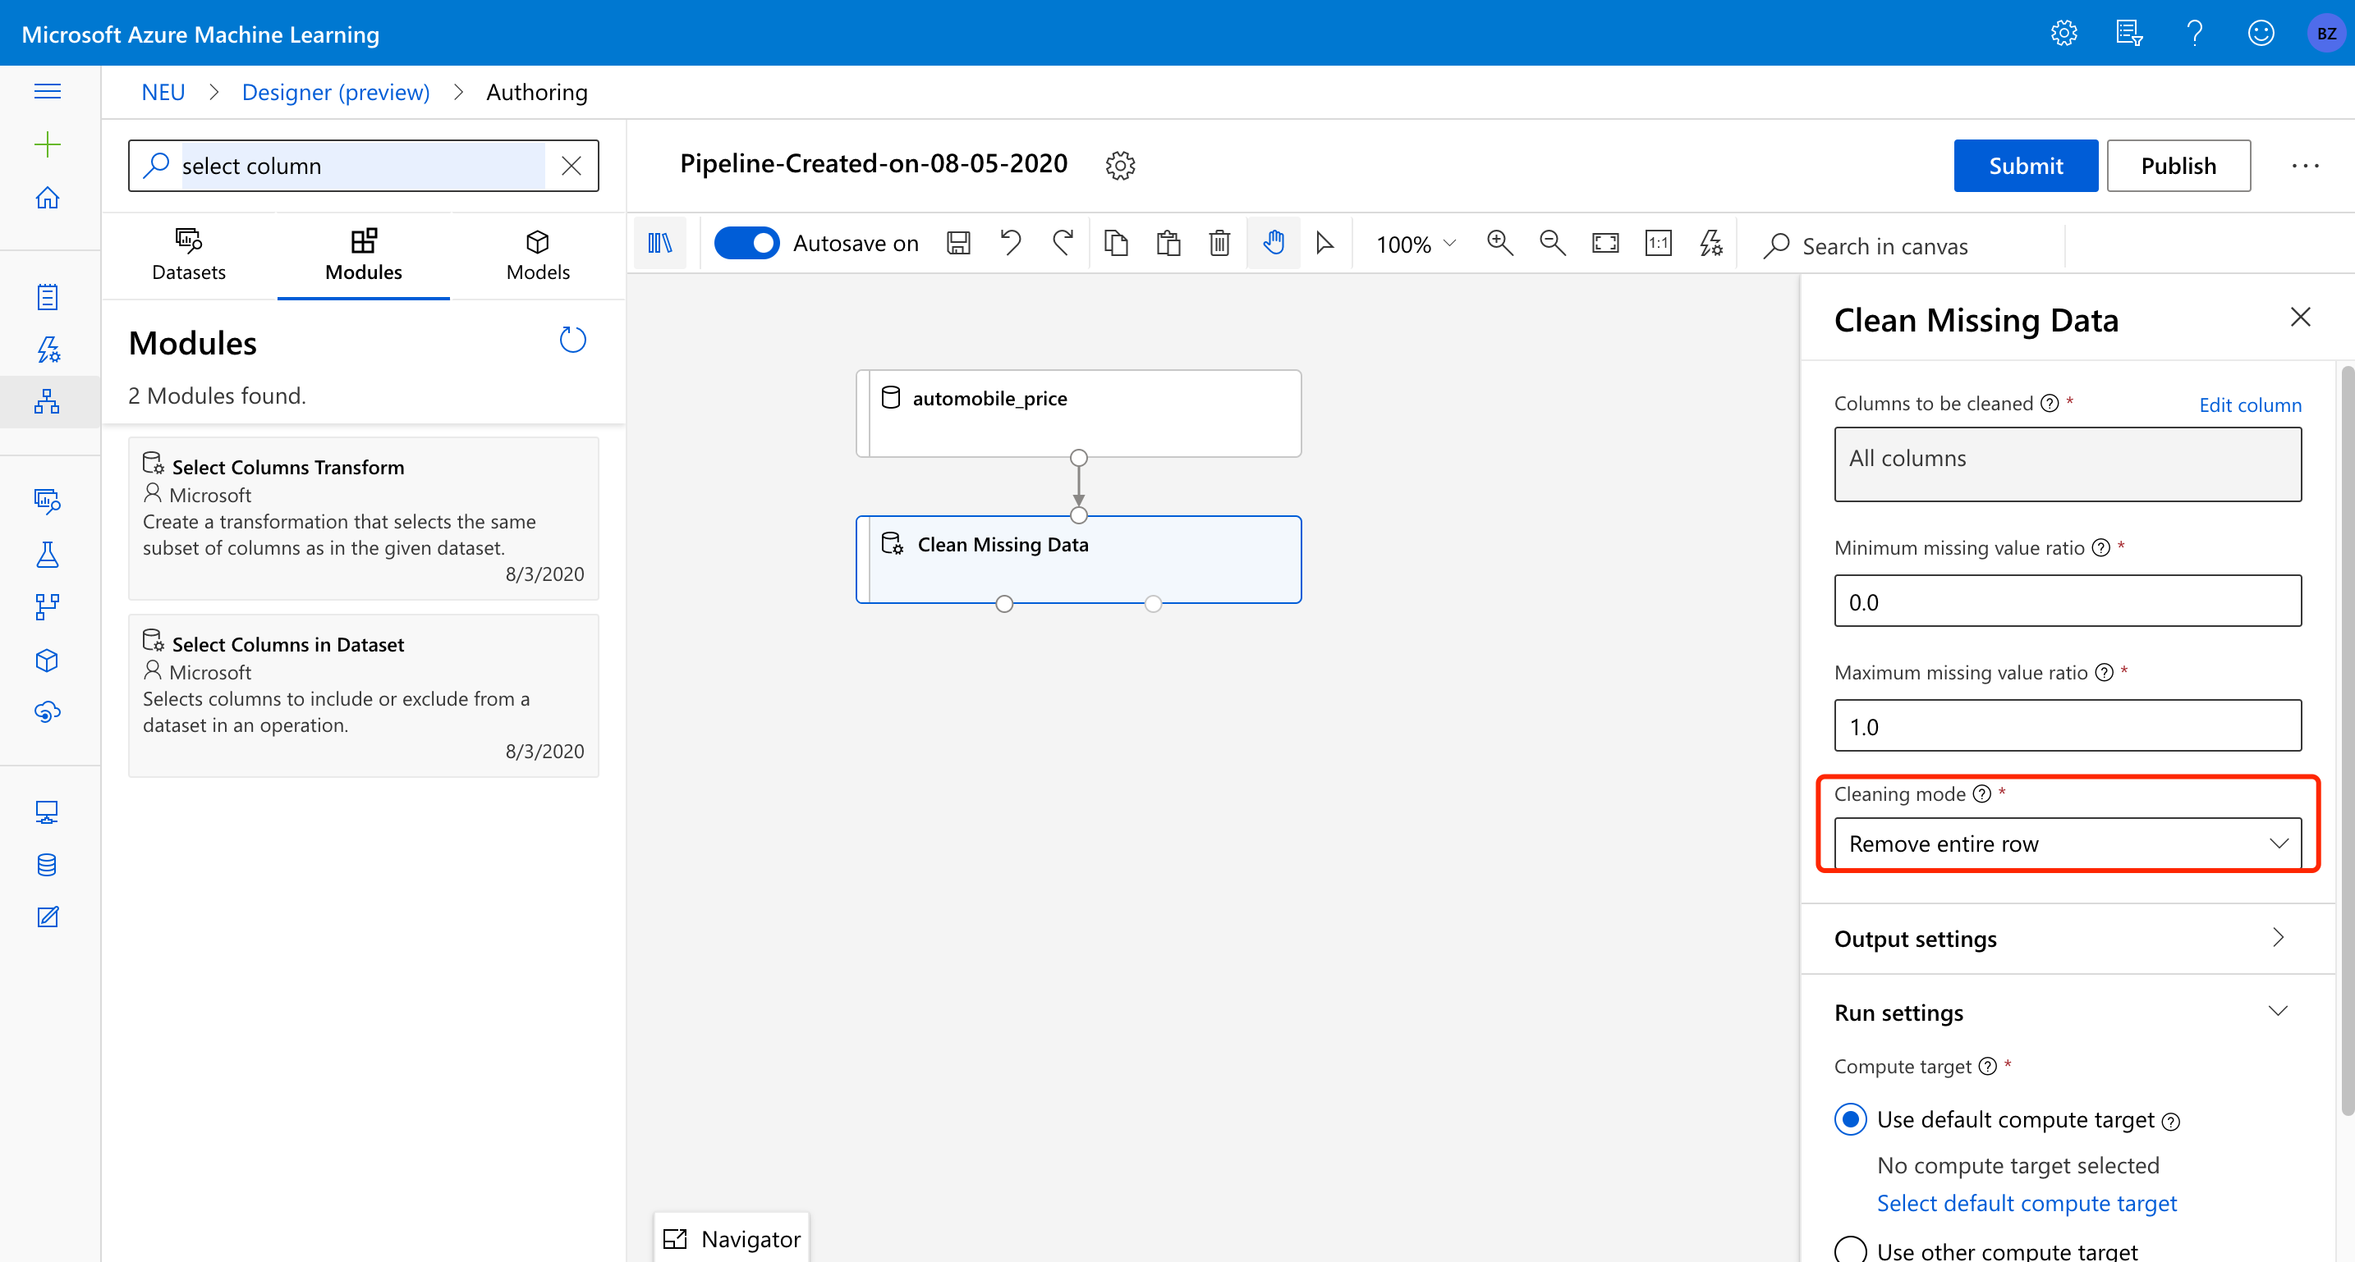

And then select 4 variables for our regression model: width, curb-weight, engine-size, horsepower. Target variable: price

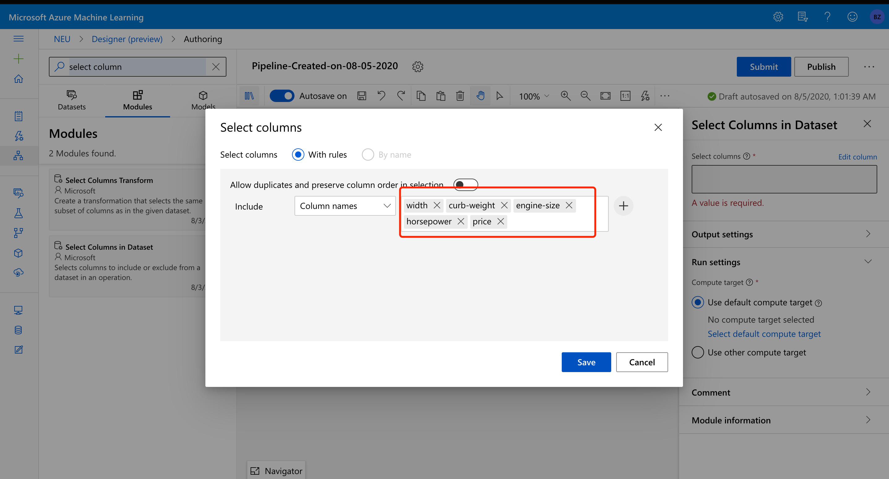

Split the data by 70% training and 30% test data:

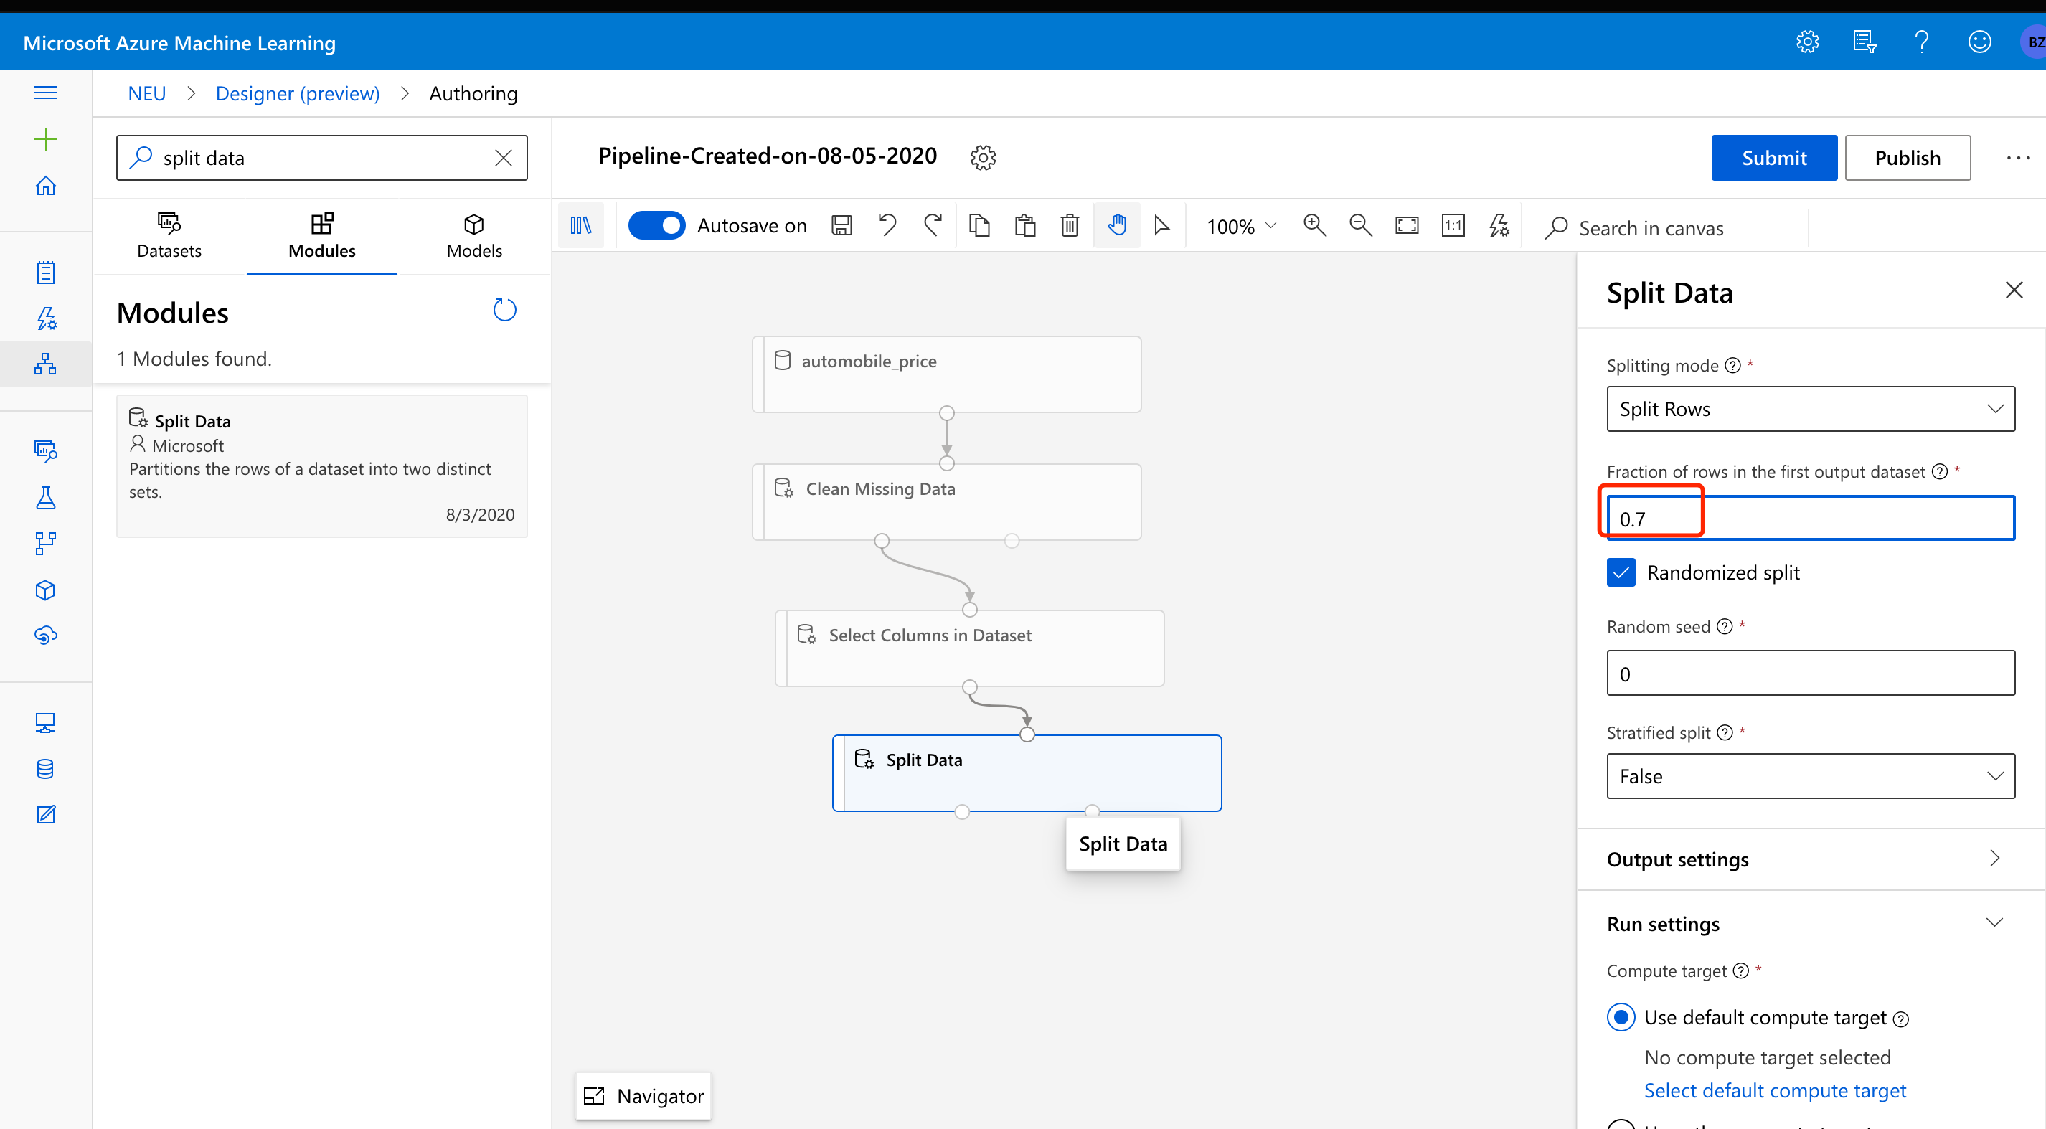

Next, we should train the model and input the label (target variable: Price):

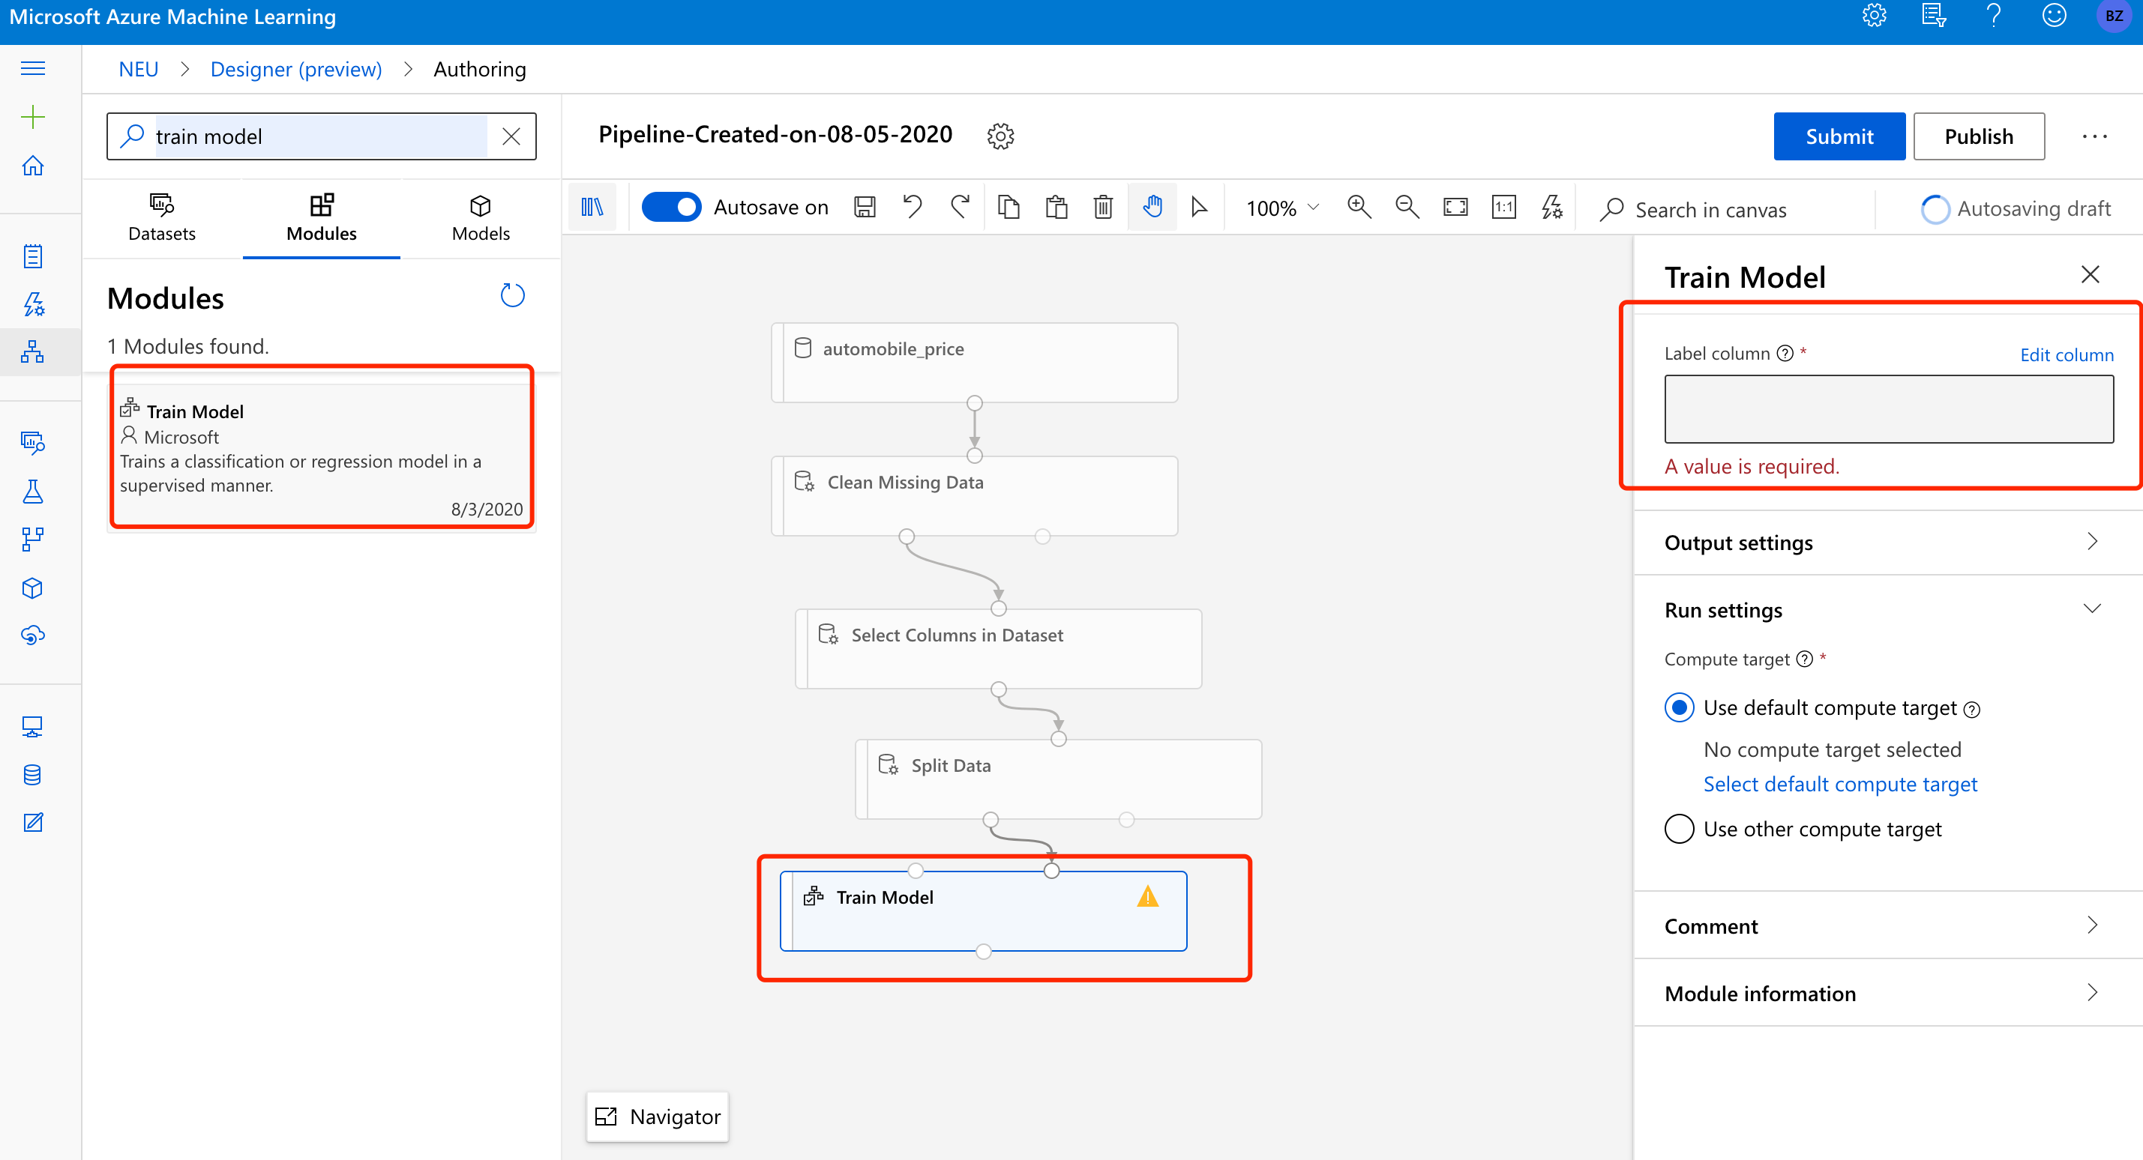

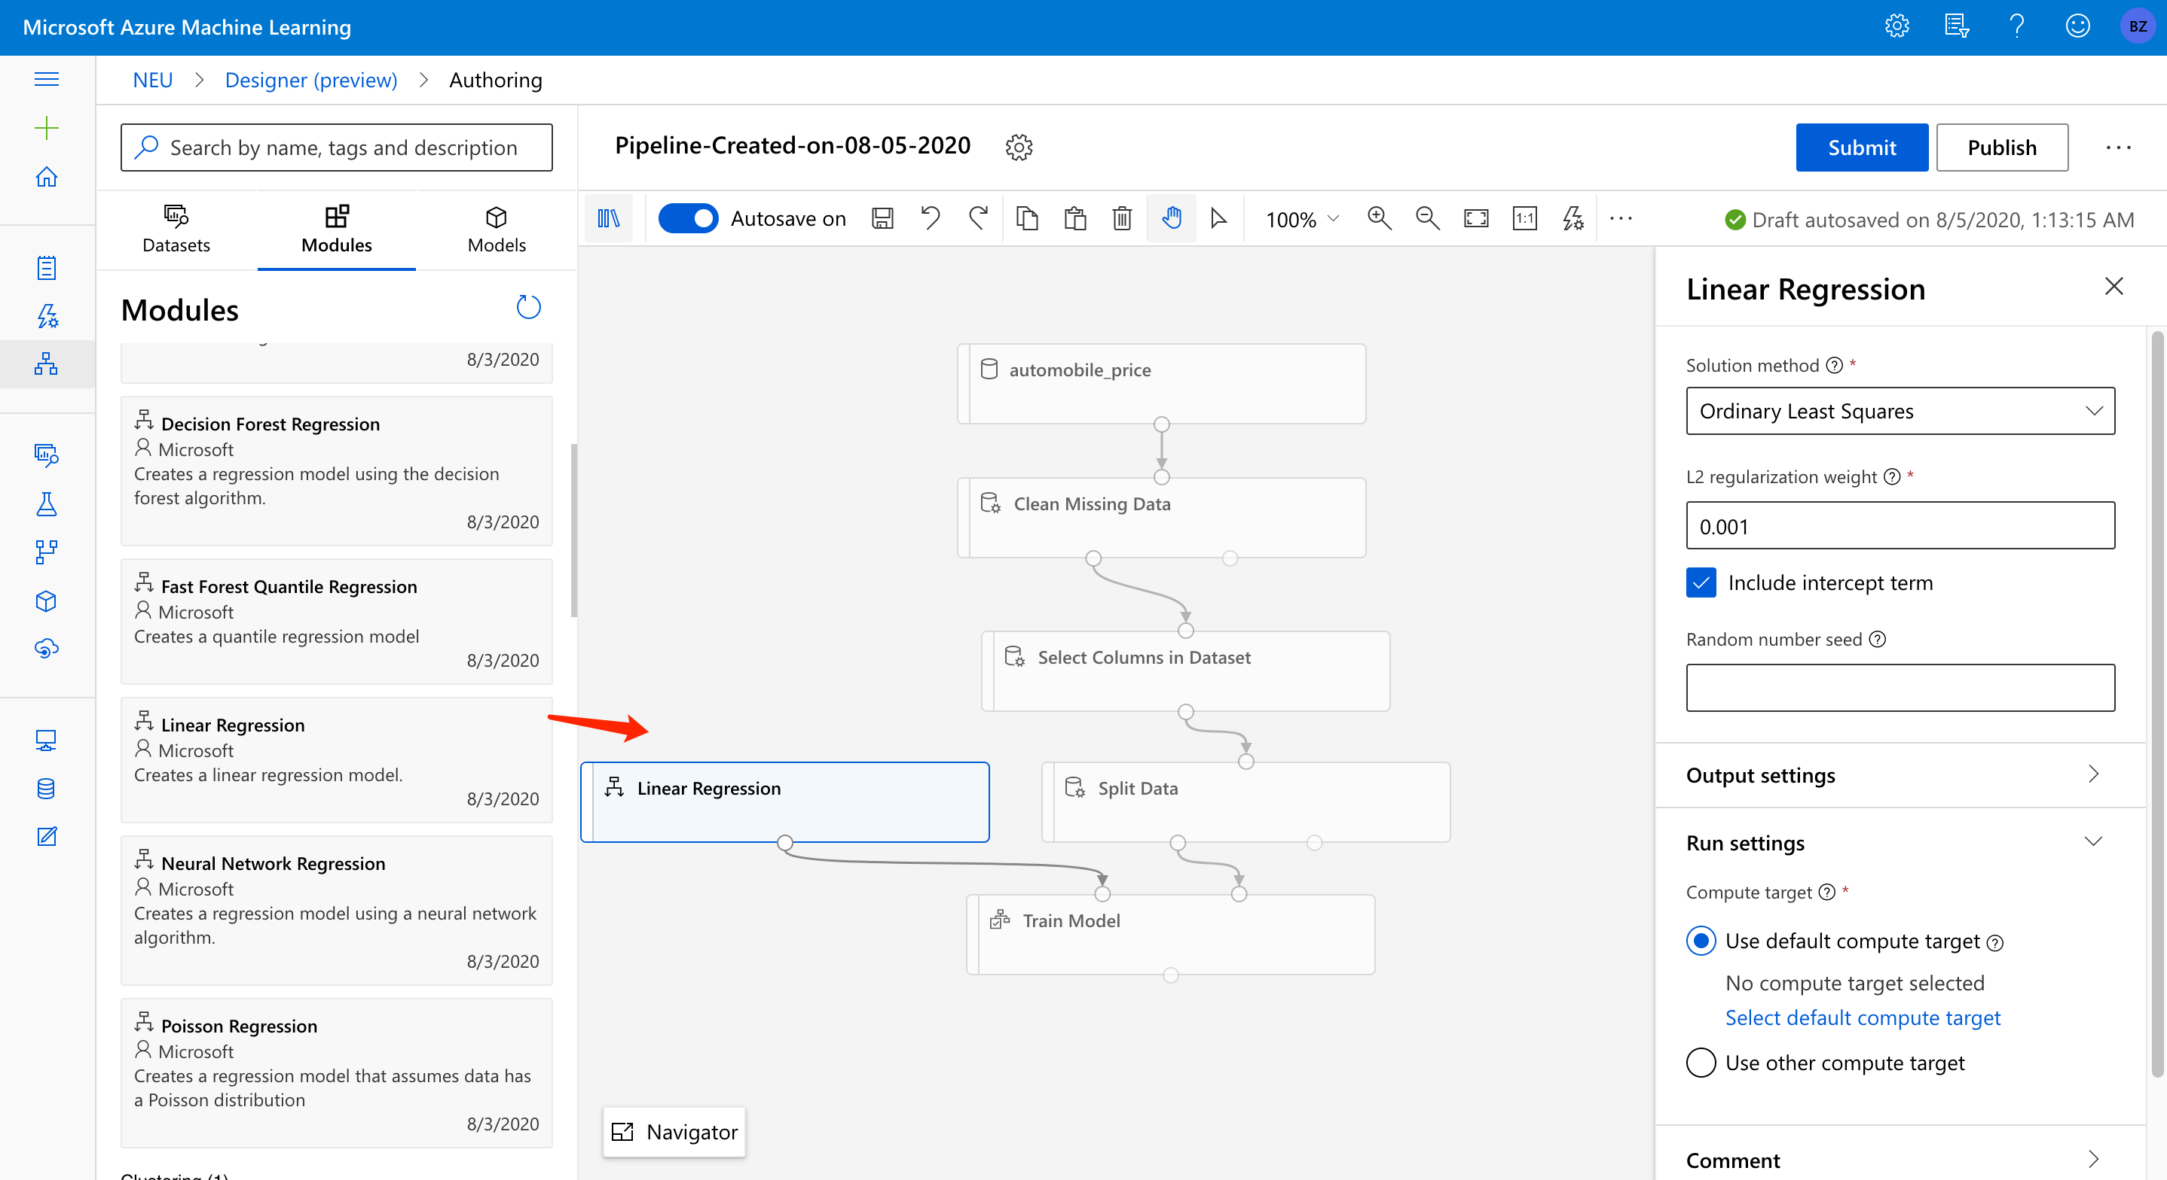

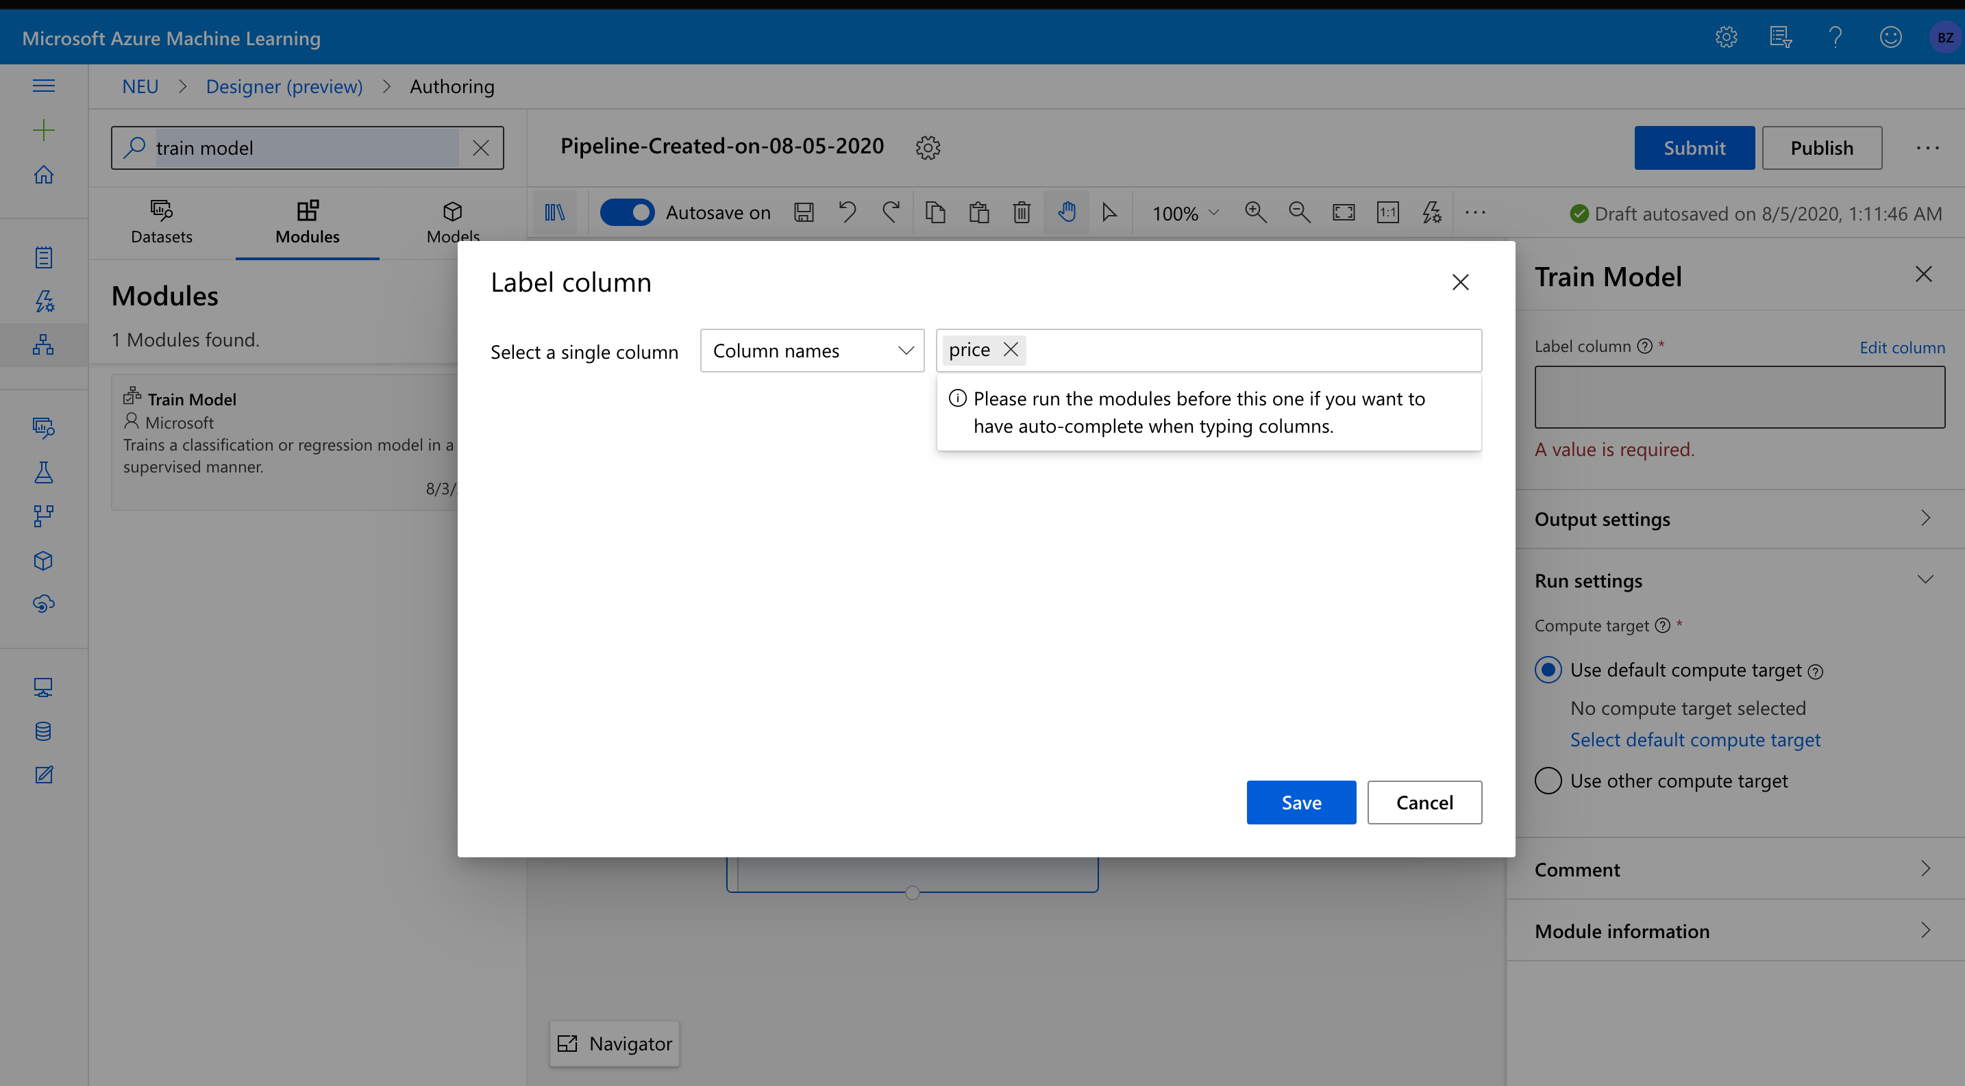

Train the model with linear regression:



The final steps are score and evaluate model:

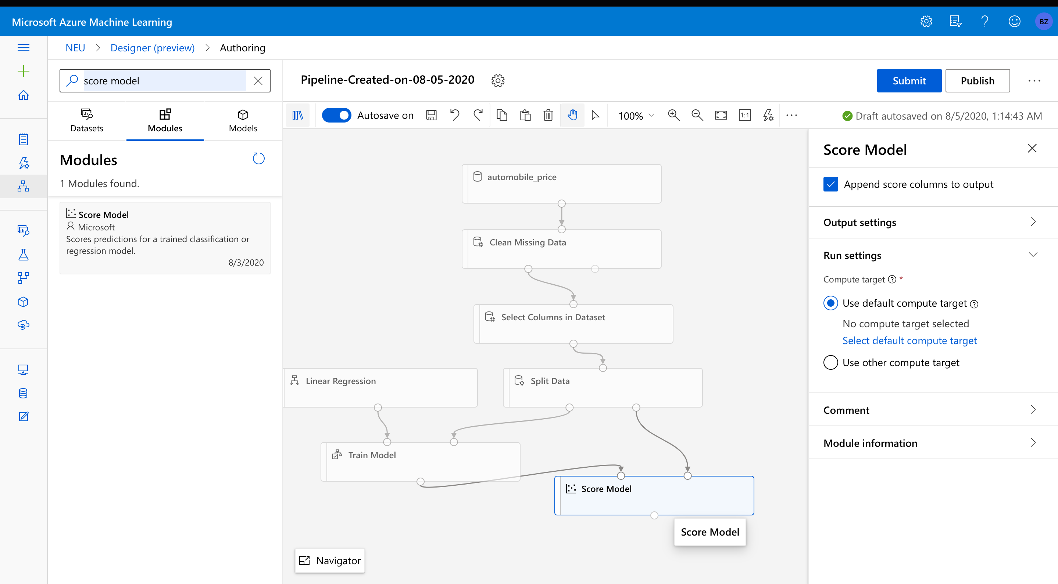

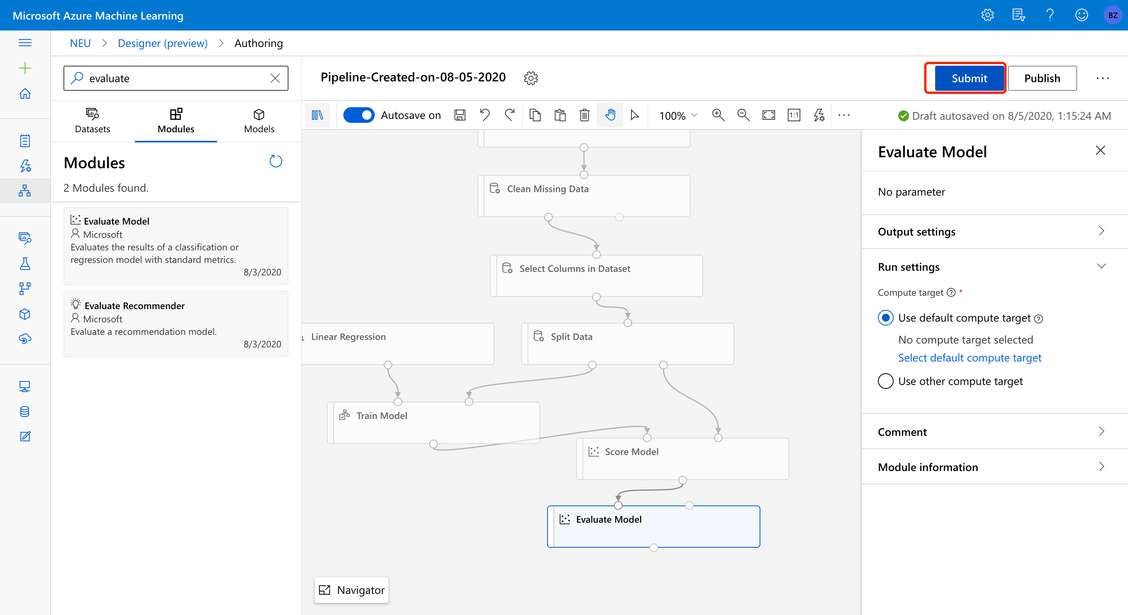

And click the submit button to run the model.

To view the result, right click the score model and visualize the LR model:

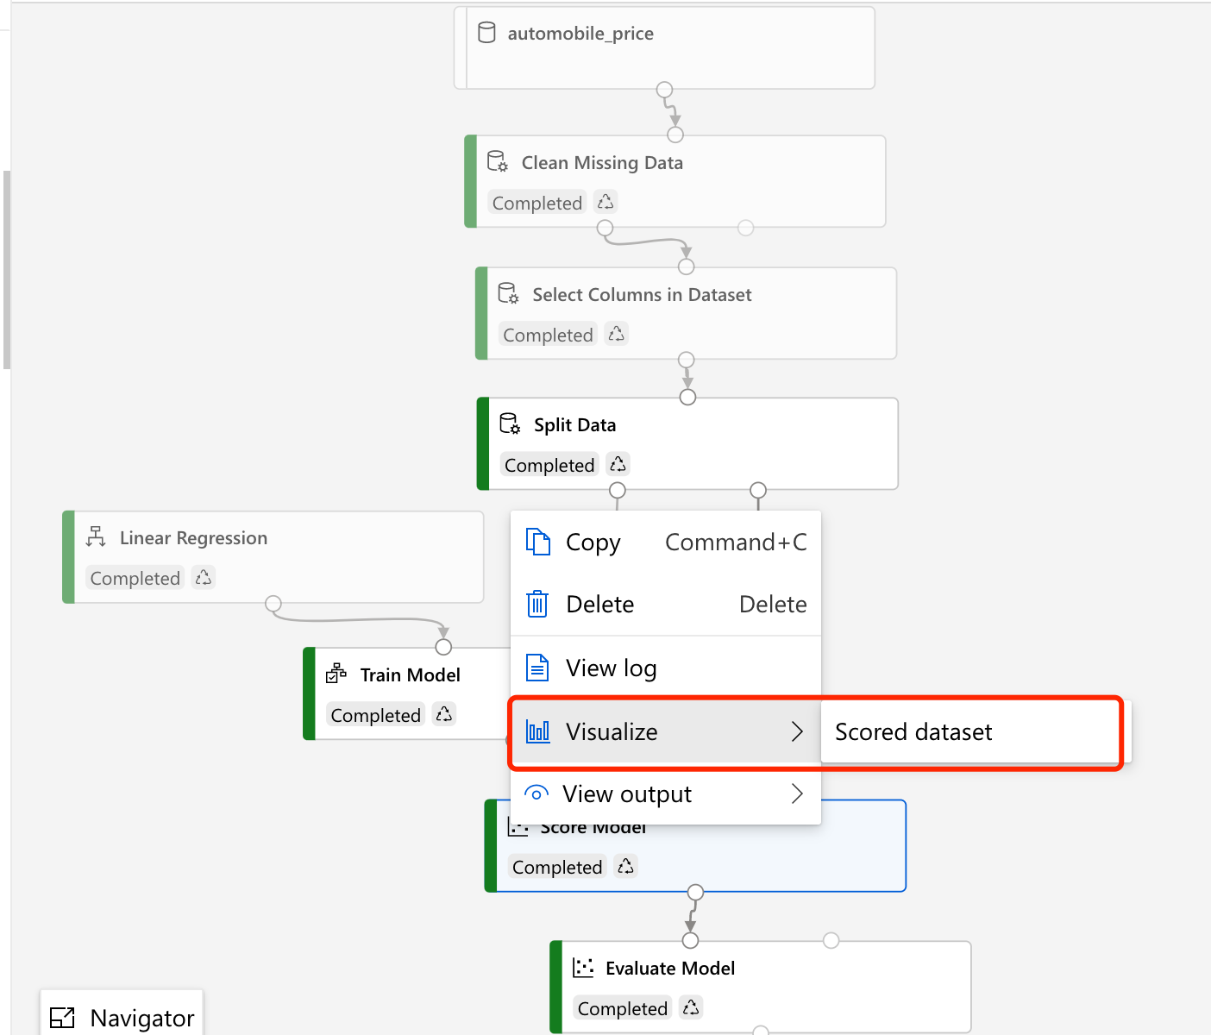

We can see the predicted prices and model evaluation below: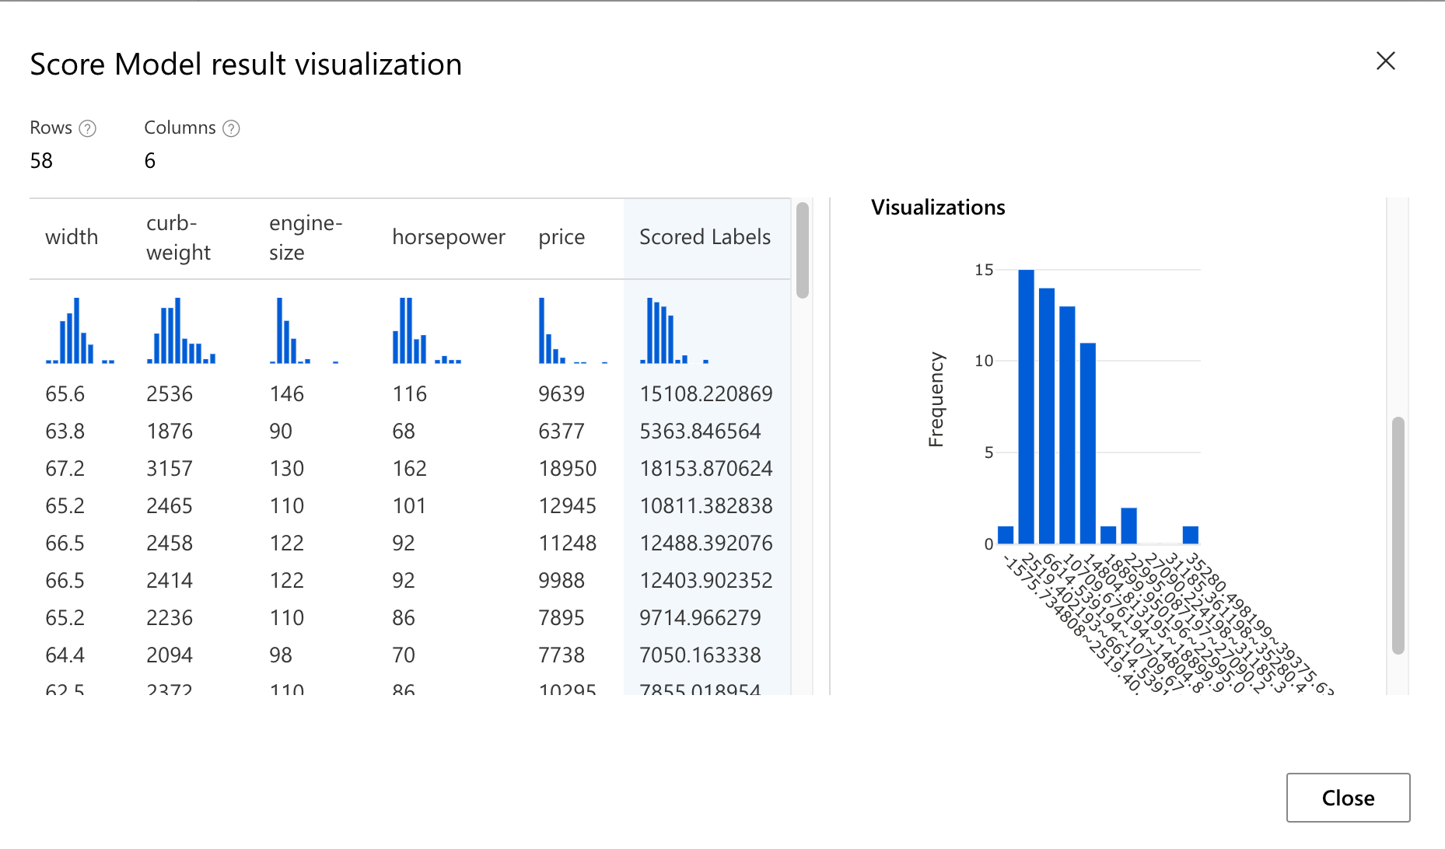 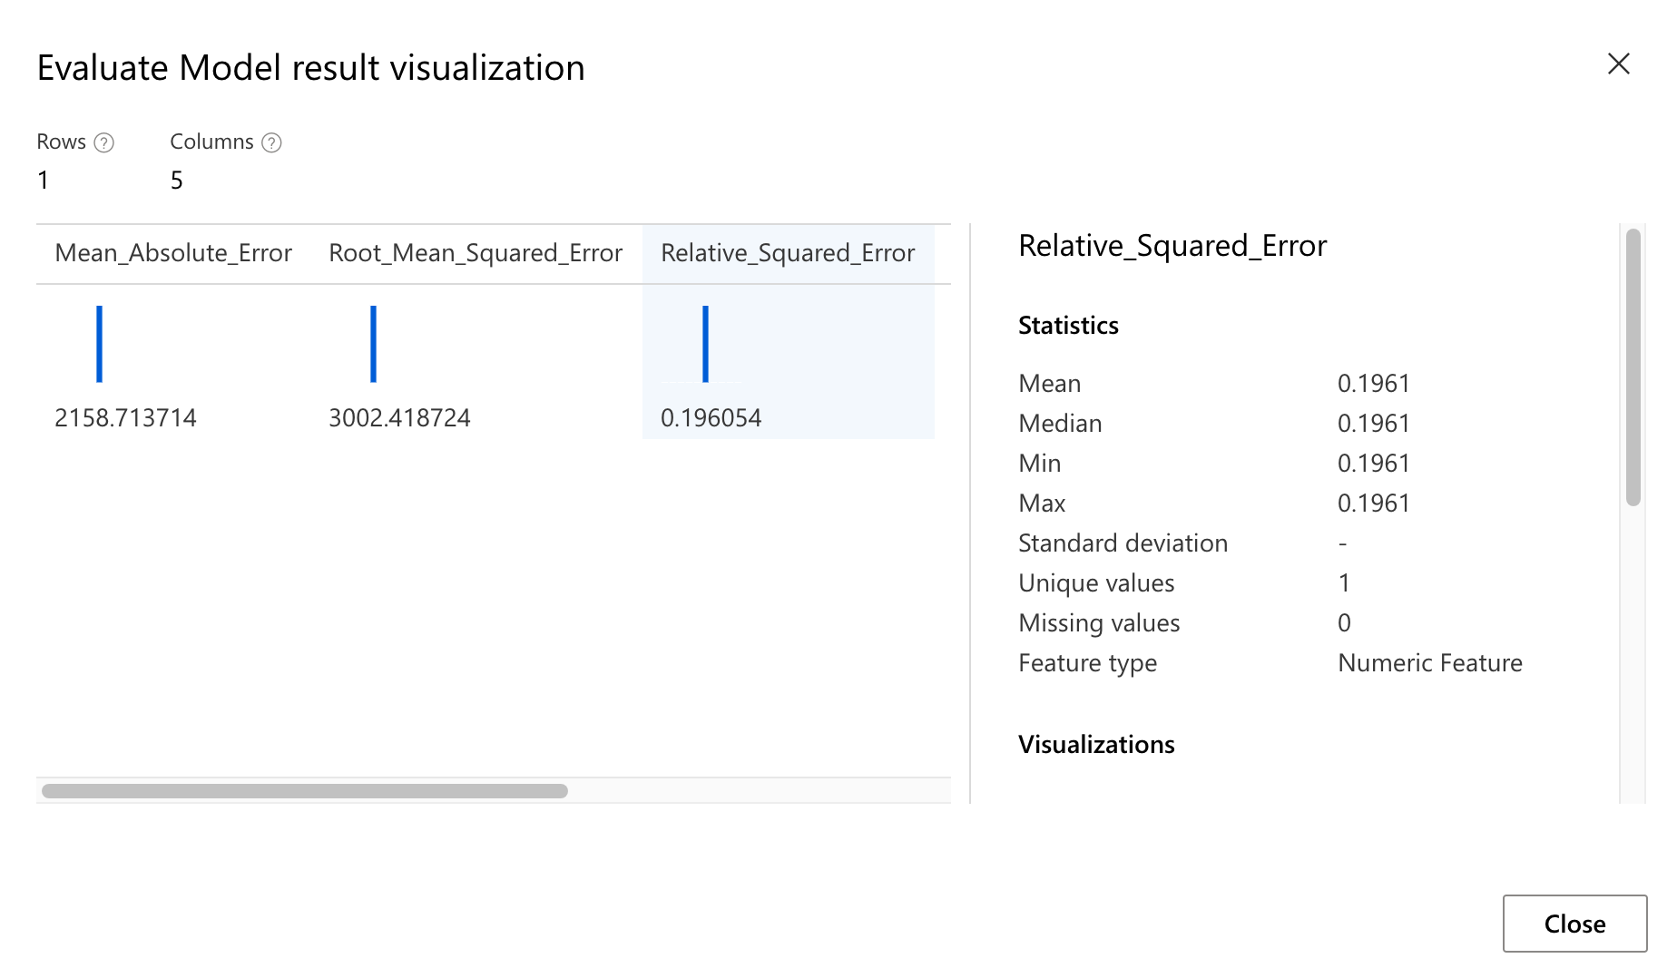

Then we use the same pipeline replace with the Decision Forest Regression to run the model again:

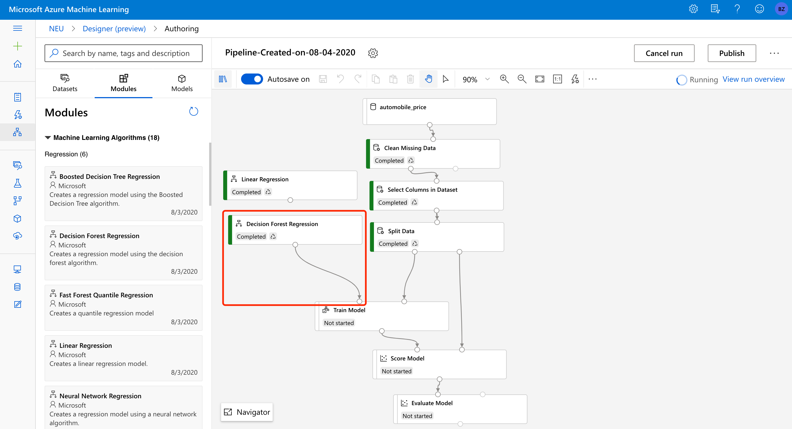

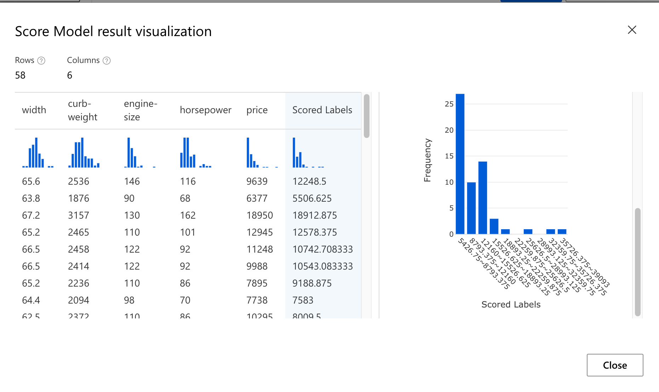

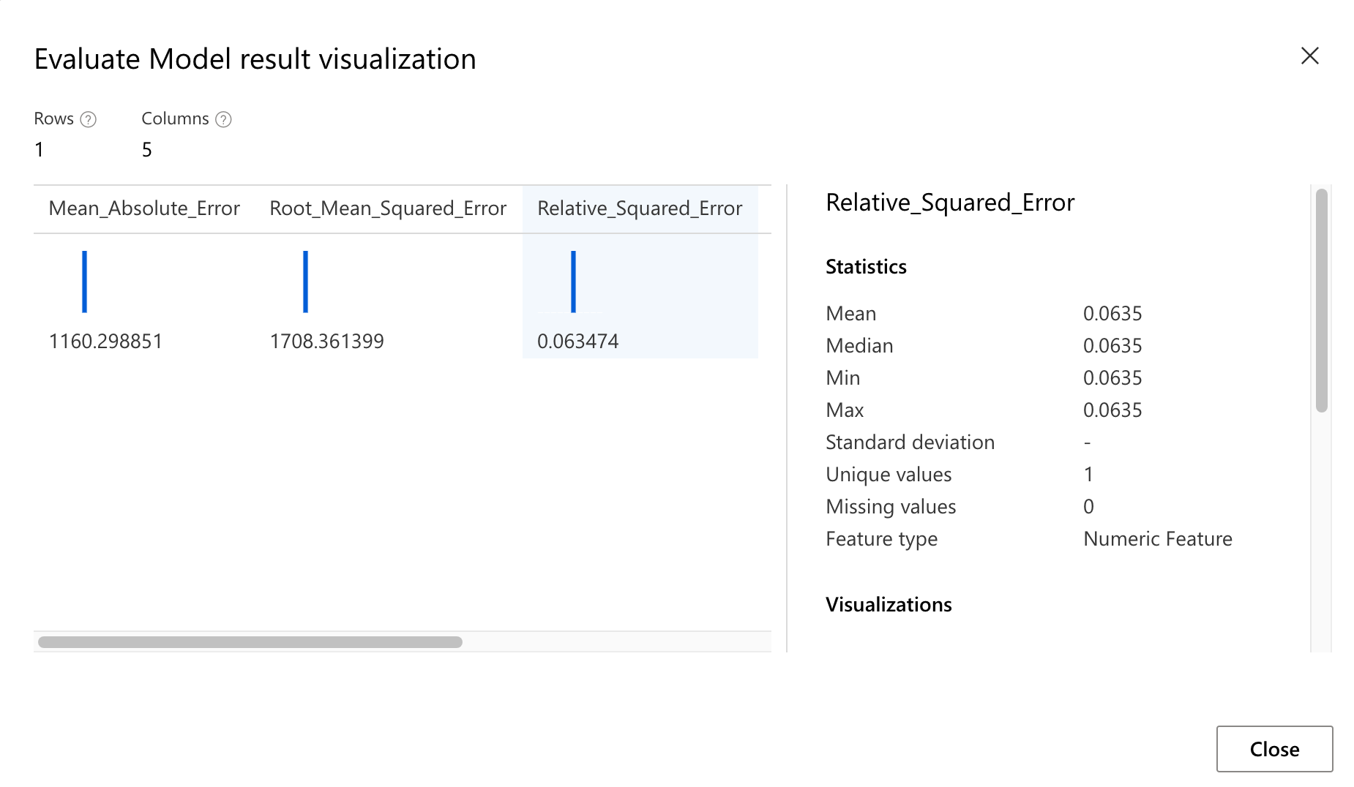

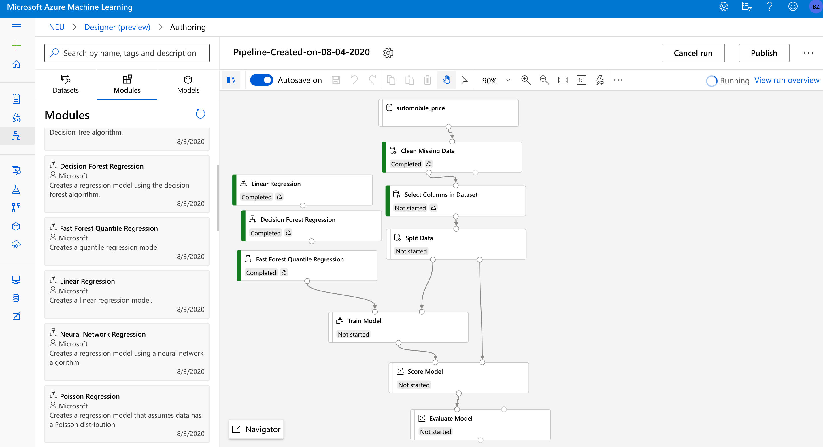

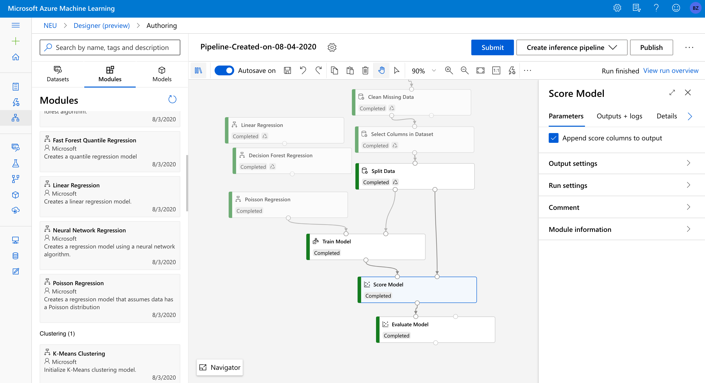

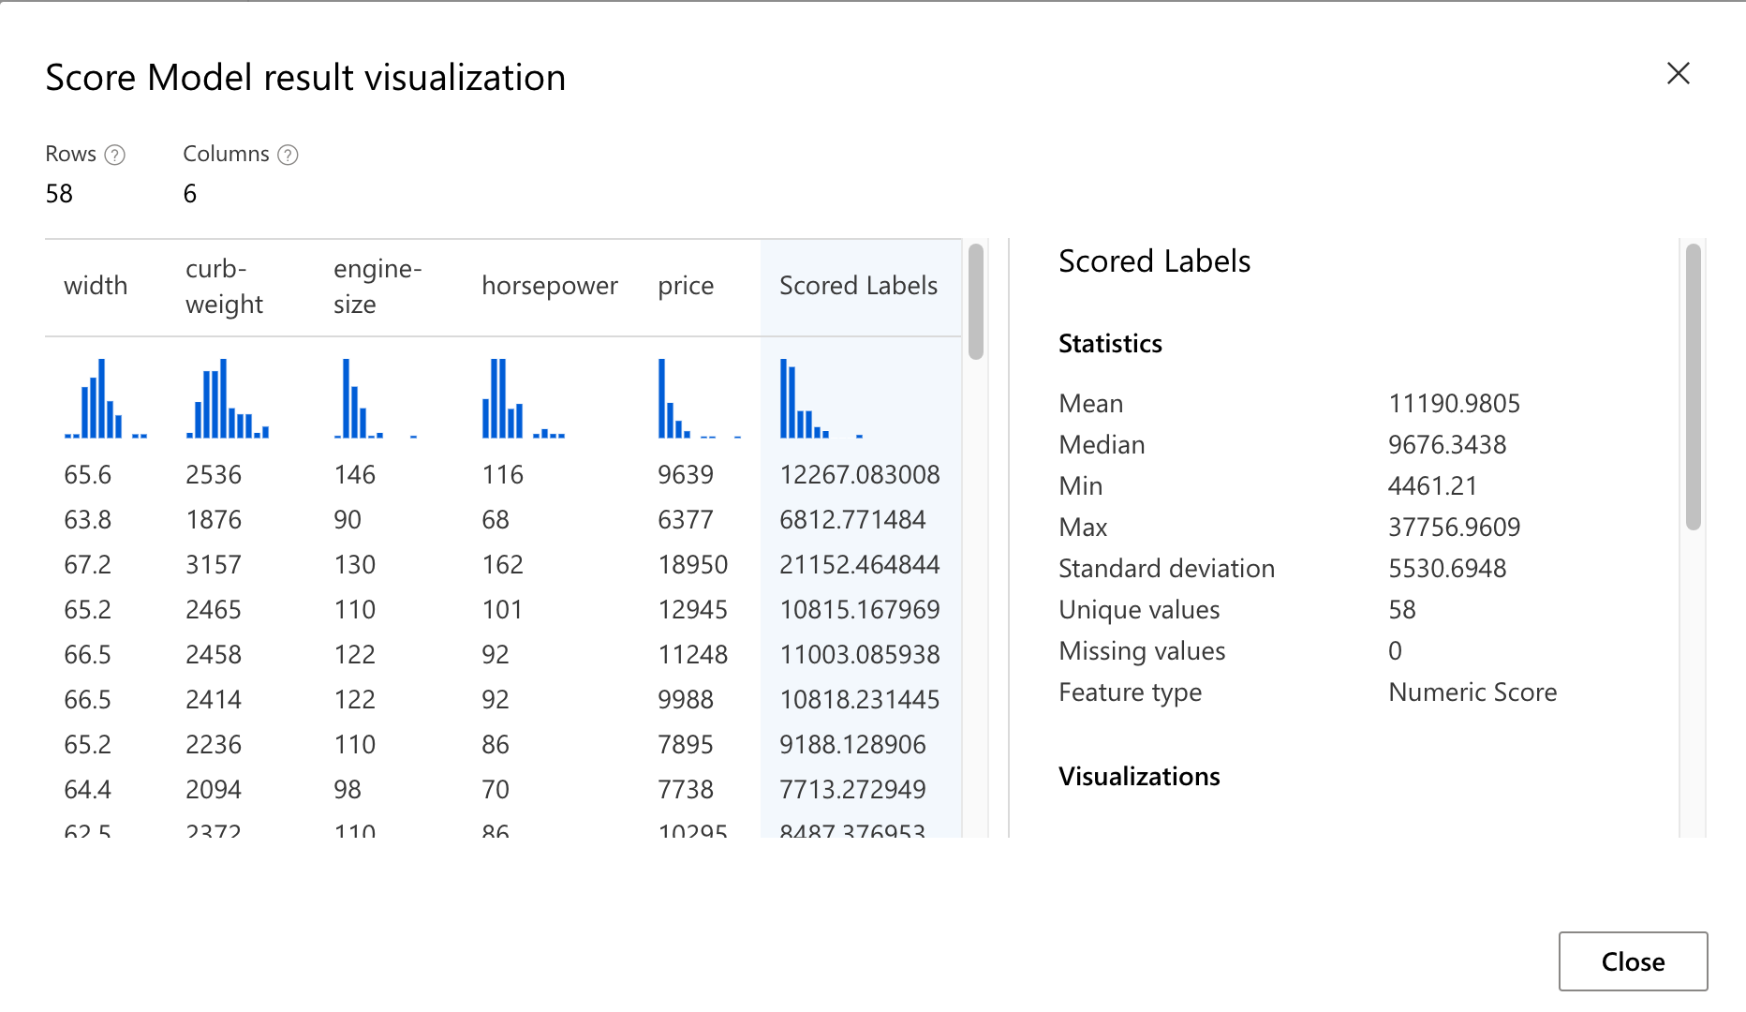

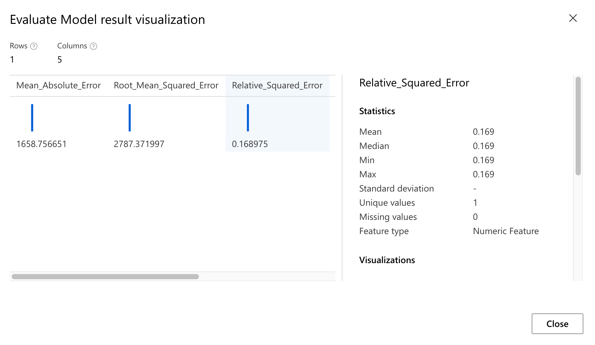

The most accurate model among these three models with selected 4 features is decision forest regression with the lowest RMSE. If we select more features for the model, the prediction performance will be different.